**DRIVER STATE SENSING SYSTEM**

*A capstone project report submitted in partial fulfillment of the requirement for the award of the degree of*

Bachelor of Engineering

*in*

Electronics and Communication Engineering

**Submitted By**

Harsheen Kaur (401906011)

Aditi Puri (402086003)

Mansi Gupta (401906013)

Yashna Bawa (401906018)

Mridul Sharma (401906014)

(Group No – 85)

*Under the Supervision of*

**Dr. Dinesh** (Assistant Professor, ECED)

**Dr. Debabrata Gosh** (Assistant Professor, ECED)



Department of Electronics and Communication Engineering

THAPAR INSTITUTE OF ENGINEERING & TECHNOLOGY, PATIALA, PUNJAB

August 2022

**TABLE OF CONTENTS**

DECLARATION……………………………………………………………………...………………...5 ACKNOWLEDGEMENT.…………………………………………………………...…………………6

ABSTRACT…………………………………………………………………………………………….7LIST OF FIGURES…………………………………..………………………………………………....8

LIST OF TABLES………………………………………………………………………………..........10

LIST OF ABBREVIATIONS…………………………………………………………..……………...11

**CHAPTER 1- INTRODUCTION...................................................................................................1****2**

1.1 PROJECT OVERVIEW...............................................................................................................12

1.2 MOTIVATION...............................................................................................………………….13

1.3 ASSUMPTIONS AND CONSTRAINTS...................................................................................13

1.4 NOVELTY OF WORK.................................................................................………………..….15

**CHAPTER 2 – LITERATURE SURVEY.......................................................................................****16**

2.1 LITERATURE SURVEY..............................................................................................................16

2.1.1 THEORY ASSOCIATED WITH PROBLEM AREA..............................................…..16

2.1.2 SAMPLE TABLE FOR LITERATURE SURVEY...............................................……..16

2.1.3 THE PROBLEM THAT HAS BEEN IDENTIFIED.................................................…..17

2.2 RESEARCH GAPS.........................................................................................................................18

2.3 PROBLEM DEFINITION.........................................................................…..……………………18

2.4 REQUIREMENTS SPECIFICATION ....................................................................... 18

2.4.1 INTRODUCTION..........................................................................................19

2.4.1.1 PURPOSE........................................................................................19

2.4.1.2 INTENDED AUDIENCE AND READING SUGGESTIONS .....................19

2.4.1.3 PROJECT SCOPE...........................................................................19

2.4.2 OVERALL DESCRIPTION.....................................................................................20

2.4.2.1 PRODUCT PERSPECTIVE..........................................................20

2.4.3 EXTERNAL INTERFACE REQUIREMENTS...........................................21

2.4.3.1 SOFTWARE REQUIREMENTS ...................................................................21

2.4.3.2 HARDWARE INTERFACES ...................................................... 21

2.4.4 OTHER NON-FUNCTIONAL REQUIREMENTS .....................................22

2.4.4.1 PERFORMANCE REQUIREMENTS...............................................................22

2.5 APPROVED OBJECTIVES…………………………………………………………..……….22

2.6 PROJECT OUTCOMES AND DELIVERABLES.........................................…..………………...23

2.7 COST ANALYSIS......................................................................................................................…..24

2.8 RISK ANALYSIS.........................................................................................................................…24

**CHAPTER 3 – FLOW CHART…………………………………………………………………….27**

3.1 SYSTEM ARCHITECTURE……………………………………………………………..………27

3.2 ANALYSIS………………………………………………………………………………….……..28

3.3 TOOLS AND TECHNOLOGIES USED…………………………………………………………29

**CHAPTER 4 – PROJECT DESIGN AND DESCRIPTION…………………………………..…..30**

4.1 DESCRIPTION …………………………………………………………………………………30

4.2 U.G SUBJECTS……….……………………………………………………………………..……30

4.3 STANDARDS USED………………………………….………………………………………..…30

4.4 SURVEY OF TOOLS AND TECHNOLOGIES .........................................................31

4.4.1 ULTRASONIC SENSOR COMPARISONS…………………………………………..31

4.4.1.1 ULTRASONIC SENSOR (HCSR04) ………………………………………….31

4.4.1.2 WORKING PRINCIPLE …………………………………………..………31

4.4.1.3 SPECIFICATIONS ………………………………………………………..32

4.4.2 CAR DASH CAMERA COMPARISONS …………………………………………….32

4.4.2.1 DASHCAM …………………………………………………………………..32

4.4.2.2 WORKING PRINCIPLE ……………………………………………………..33

4.4.2.3 SPECIFICATIONS ……………………………………….…………………35

4.4.3 LCD DISPLAY……….…………………......................................…….35

4.4.3.1 16x2 LCD DISPLAY …………………….................................….35

4.4.3.2 WORKING PRINCIPLE……………………………..……………………36

4.4.3.3 SPECIFICATIONS ……………………………………………………………36

4.4.4 MULTIMEDIA SPEAKER……….…………………...............…….37

4.4.4.1 MULTIMEDIA SPEAKER ……………………..............................….37

4.4.4.2 WORKING PRINCIPLE……………………………..……………………37

4.4.4.3 SPECIFICATIONS ……………………………………………………………38

4.4.5 BUZZER……….……………………...................................................….38

4.4.5.1 BUZZER...........…………………….......................................................….38

4.4.5.2 WORKING PRINCIPLE……………………………..……………………38

4.4.5.3 SPECIFICATIONS ……………………………………………………………39

4.4.6 ENGINE MOTOR……….…...............................…………………….39

4.4.6.1 ENGINE MOTOR ……………..............................................………….39

4.4.6.2 WORKING PRINCIPLE……………………………..……………………40

4.4.6.3 SPECIFICATIONS ……………………………………………………………40

4.4.7 VIBRATION MOTOR…………......................................……………..41

4.4.7.1 VIBRATION MOTOR..........…………….......................................………….41

4.4.7.2 WORKING PRINCIPLE……………………………..……………………41

4.4.7.3 SPECIFICATIONS ……………………………………………………………42

4.4.8 AMPLIFIER……….……...................................................……………….42

4.4.8.1 AMPLIFIER …………......................................................…………….42

4.4.8.2 WORKING PRINCIPLE……………………………..……………………43

4.4.8.3 SPECIFICATIONS ………………………………………………………44

4.4.9 ARDUINO UNO COMPARISONS …………………………………………………44

4.4.9.1 ARDUINO UNO MODULE ……………………………………………44

4.4.9.2 SPECIFICATIONS …………………………………………………………47

4.4.9.3 WORKING PRINCIPLE ……………………………………………………45

**CHAPTER 5 – IMPLEMENTATION & EXPERIMENTAL RESULT .........................45**

5.1 CIRCUIT STIMULATION ..........................................................................................45

5.1.1 ULTRASONIC SENSOR SIMULATION............................................................45

5.1.2 DISTRACTION DETECTION SIMULATION… ....................................................46

5.1.3 YAWN DETECTION SIMULATION….....................................................................48

5.1.4 ARDUINO UNO MODULE… .........................................................................................50

5.2 PYTHON CODE SIMULATION................................................................................52

5.2.1 FLOW CHART OF CODE APPROACH…................................................................52

5.2.2 FUNCTIONS USED IN THE CODE…................................................................53

5.2.3 OUTPUT................................................................................................................59

**CHAPTER 6 – OUTCOME AND PROSPECTIVE LEARNING .....................................64**

6.1 SCOPE AND OUTCOMES… ...................................................................................64

6.2 PROSPECTIVE LEARNINGS..................................................................................64

6.3 CONCLUSION….......................................................................................................6

**CHAPTER 7 – PROJECT TIMELINE …………………...………………………………………..33**

7.1 WORK BREAKDOWN …………………………………………………………………………33

7.2 GANTT CHART ………………………………………………………………………………..36

7.3 INDIVIDUAL GANTT CHART................................................................................67

7.4 PROJECT TIMELINE …………………………………………………………………………..37

**REFERENCES………………………………………......………………………………………….60**

## DECLARATION

We hereby declare that the capstone project group report title “Driver State Sensing system” is an authentic record of our work carried out at “Thapar Institute of Engineering and Technology, Patiala” as a Capstone Project in the seventh semester of B.E. (Electronics & Communication Engineering), under the guidance of “**Dr. Dinesh”** and **“Dr. Debabrata Gosh”**, during January to December 2022.

|  |  |  |
| --- | --- | --- |
| **NAME** | **ROLL NO.** | **SIGNATURE** |
| Harsheen Kaur | 401906011 |  |
| Aditi Puri | 402086003 |  |
| Mansi Gupta | 401906013 |  |
| Yashna Bawa | 401906018 |  |
| Mridul Sharma | 401906014 |  |

## ACKNOWLEDGEMENT

Every project is accomplished through the hard work and efforts of the respective group members and many more involved. We are highly indebted to our teachers. Our group would like to express gratitude and appreciation to all those who allowed us to complete this report. Special thanks to **Dr. Debabrata Gosh** and **Dr. Dinesh** for being our constant companions and encouraging us in every part and problem. We also sincerely thank them for their devoted time. We would like to express our gratitude to Capstone Laboratory Department for giving us permission and the necessary equipment for our project. We heartily thank our capstone heads, Mr. Vinay Kumar and Dr. Poonam Verma, for their kind support. Without them, we would not have reached this stage.

|  |  |  |
| --- | --- | --- |
| **NAME** | **ROLL NO.** | **SIGNATURE** |
| Harsheen Kaur | 401906011 |  |
| Aditi Puri | 402086003 |  |
| Mansi Gupta | 401906013 |  |
| Yashna Bawa | 401906018 |  |
| Mridul Sharma | 401906014 |  |

## ABSTRACT

Distraction was a factor in 9 percent of fatal crashes reported in 2021.

Every day 6 people die in India from distracted driving. texting and calling while driving is becoming a huge problem and monitoring a driver's face and eyes could help save thousands of lives every year. Distracted driving has been identified as an important risk factor in road traffic injuries. Mobile phone usage has developed into a primary source of driver distraction as it can induce drivers to take their attention off the road, thus making vehicle occupants more vulnerable to road crashes. This is an alarming statistic, but doubly concerning for fleet managers with multiple vehicles and drivers in their charge. They need technology to minimize the risk of accidents while still ensuring prompt and efficient service to meet their responsibility for the continued safety of the drivers and vehicles under their supervision.

A Driver monitoring system is a blanket term for a system that uses AI to analyze driver behavior primarily using the internal-facing camera. Currently, the emphasis is on enforcing requirements such as putting on seatbelts or discouraging behaviors like looking at cellphones or tuning the radio while driving. AI dash cams detect the telltale patterns of these actions and issue an alert as a gentle reminder to the driver and add record in the driver logs.

With a goal to reduce traffic accidents and improve transportation safety, the driver distraction detection system identifies various types of distractions through a camera observing the driver. An assisted driving testbed will be developed for the purpose of creating realistic driving experiences and validating the distraction detection algorithms.

A dataset which consists of images of the drivers in both normal and distracted driving postures will be collected. Various traditional machine learning techniques will be implemented to detect driver distraction. We adopt CNN models to classify driving activities. The input to each CNN model contains the pixel values of the input image. In addition, a conversational warning system will also be developed that alerts the driver in real-time when he/she does not focus on the driving task.

**LIST OF FIGURES**

|  |  |  |
| --- | --- | --- |
| FIGURE NO. | CAPTION | PAGE NO. |
| Figure 1.1 | Features of the driver monitoring system | 14 |
| Figure 2.1 | Flowchart of proposed system | 23 |
| Figure 3.1 | Flowchart | 26 |
| Figure 4.1 | Ultrasonic sensor | 31 |
| Figure 4.2 | Ultrasonic sensor Pin Configuration | 32 |
| Figure 4.3 | Dashcam | 32 |
| Figure 4.4 | Video Acquisition | 33 |
| Figure 4.5 | Face detection | 34 |
| Figure 4.6 | Eyes detection | 34 |
| Figure 4.7 | Head position detection | 34 |
| Figure 4.8 | EAR calculation | 34 |
| Figure 4.9 | Drowsiness detection | 34 |
| Figure 4.10 | Inattentive detection | 34 |
| Figure 4.11 | LCD display | 35 |
| Figure 4.12 | Speaker | 37 |
| Figure 4.13 | Buzzer | 38 |
| Figure 4.14 | Engine motor | 39 |
| Figure 4.15 | Vibration motor | 41 |
| Figure 4.16 | Amplifier | 42 |
| Figure 4.17 | Amplifier Working | 44 |
| Figure 4.18 | Arduino UNO | 45 |
| Figure 4.19 | Arduino UNO Pinout | 46 |
| Figure 5.1 | Circuit Components | 48 |
| Figure 5.2 | Distraction detection simulation | 48 |
| Figure 5.3 | Yawn detection simulation | 49 |
| Figure 5.4 | Ultrasonic sensor simulation | 49 |
| Figure 5.5 | Flowchart of code approach | 52 |
| Figure 7.1 | Gantt Chart | 58 |
| Figure 7.2 | Gantt Chart (Harsheen kaur) | 58 |
| Figure 7.3 | Gantt Chart (Aditi Puri) | 58 |
| Figure 7.4 | Gantt Chart (Mansi Gupta) | 59 |
| Figure 7.5 | Gantt Chart (Yashna bawa) | 59 |
| Figure 7.6 | Gantt Chart (Mridul Sharma) | 59 |
| Figure 7.7 | Project timeline | 60 |

**LIST OF TABLES**

|  |  |  |
| --- | --- | --- |
| TABLE NO. | CAPTION | PAGE NO. |
| Table 2.1 | Sample table for literature survey | 17 |
| Table 2.2 | Cost Analysis | 24 |
| Table 4.1 | Specifications of speaker | 38 |
| Table 4.2 | Specifications of engine motor | 40 |
| Table 4.3 | Specifications of vibration motor | 42 |
| Table 4.4 | Specifications of amplifier | 43 |
| Table 4.5 | Specifications of Arduino | 47 |
| Table 5.1 | Work breakdown | 57 |
| Table 5.2 | Course learning outcomes | 61 |

**LIST OF ABBREVIATIONS**

|  |
| --- |
| ECG Electrocardiography |
| EEG Electroencephalography |
| FYP Final Year Project |
| MIROS Malaysia Institute of Road Safety |
| PERCLOS Percentage of eye Closure |
| IEEE Institute of Electrical and Electronics Engineers |
| GPS Global Positioning System |
| WBSN Wireless Body Sensor Network |
| GPRS General Packet Radio System |
| IR Infrared Rays |
| GUI Graphic Unit Interface |
| WHO World Health Organization |
| IEC International Electrotechnical Commission |
| UI User Interface |
| PPG Photoplethysmography |

**CHAPTER 1**

**INTRODUCTION**

**1.1  PROJECT OVERVIEW**

In recent years, driver drowsiness has been one of the significant causes of road accidents and can lead to severe physical injuries, deaths, and substantial economic losses. Statistics indicate the need for a reliable driver drowsiness detection system that could alert the driver before a mishap happens. Researchers have attempted to determine driver drowsiness using the following measures: (1) vehicle-based measures, (2) behavioral measures, and (3) physiological measures. A detailed review of these measures will provide insight into the present system’s associated issues and the enhancements needed to make a robust system.

Distraction was a factor in 9 percent of fatal crashes reported in 2021. Every day, six people die in India from distracted driving. Texting and calling while driving is becoming a huge problem, and monitoring a driver’s face and eyes could help save thousands of lives yearly. Distracted driving has been identified as an essential risk factor in road traffic injuries. They need technology to minimize the risk of accidents while still ensuring promptness. Thus, in this paper, we propose an efficient way to survey a driver by alarming him with the help of a buzzer and an LED projection so that he gets notified and takes the necessary actions while steering.

Moreover, mobile phone usage has developed into a primary source of driver distraction as it induces drivers to focus their attention on the road, thus making vehicle occupants vulnerable to road crashes. Drowsiness-related crashes are more likely to occur during the early morning, mid-afternoon, and late at night. Many fatigue signs represent drowsy drivers, such as a driver repeatedly yawning, a driver having difficulty focusing or keeping their eyes open, and a driver having trouble keeping their head up. Our project strives to assist drivers by enhancing their driving experience and considering overall passenger safety.

**1.2. MOTIVATION**

About 1.24 million people die on the roads annually, with 20–50 million sustaining non-fatal injuries. Usually, around 21% of road accidents are caused by driving in drowsy conditions, which is one out of five road accidents. This highlights that the total number of road casualties globally is mainly due to the driver’s drowsiness and distraction, leading to significant economic loss.

So, it brings us to the question of whether there is a need to monitor the driver or not. A driver state sensing system is a blanket term for a system that uses AI to analyze driver behavior, primarily using the internal-facing camera. Currently, the emphasis is on enforcing requirements such as wearing seatbelts or discouraging behaviors like looking at cell phones or tuning the radio while driving. The AI dash cams detect these actions' tell-tale patterns, issue an alert as a gentle reminder to the driver, and add a record to the driver's logs. Intending to reduce traffic accidents and improve transportation safety, it identifies various types of distractions through a camera observing the driver, including drowsiness detection.

**1.3. ASSUMPTIONS AND CONSTRAINTS**

DRIVER STATE SENSING SYSTEM deals with monitoring the driver and downsizing road casualties.

However, there are also some weaknesses in the prototype system. The dash cam should be charged 24X7, and special care should be taken. If the face detection camera is damaged, external charges and building the prototype would be a much more tedious task.

One of the issues might arise if the driver misses the calibration step. If the system does not detect any eyes from the frame for some reason, the threshold will be set to zero. Eventually, making it impossible to see when a driver is drowsy may cause consequences. If the system is mounted too high or too low in the car, the camera may lose face detection, leading to inattentive behavior and incorrectly functioning. In another case, if the system is mounted too near to the face, the system might not be able to capture the whole look of the driver leading to false detection results. Eye blinking results and capacity may vary from one person to another.

Some of the anticipated constraints faced by the proposed system include:

* Lighting conditions: Frequent and drastic changes in the darkness or brightness of a scene (or part of it), which may happen even during the shortest driving intervals, have been proven to be a significant challenge for many computer vision algorithms.
* Camera motion: Poor Road conditions and a more aggressive style of driving can introduce a significant number of vibrations and discomfort to the driving experience. Those vibrations can be passed onto the camera and distort the images, significantly skew the results and decrease the system's overall performance.
* Relative positioning of device: The camera must be positioned within a specific range from the driver and within a particular viewing angle. Every computer vision algorithm has a “comfort zone” in which it performs the best and most reliably. If that comfort zone is left, performance can be dropped significantly.
* Hardware and software limitations: Typical mobile devices have one or two processor cores, reduced working memory, and tend to work on lower clock frequencies compared to their desktop counterparts. This reduces energy consumption but creates a significant obstacle in designing this system.

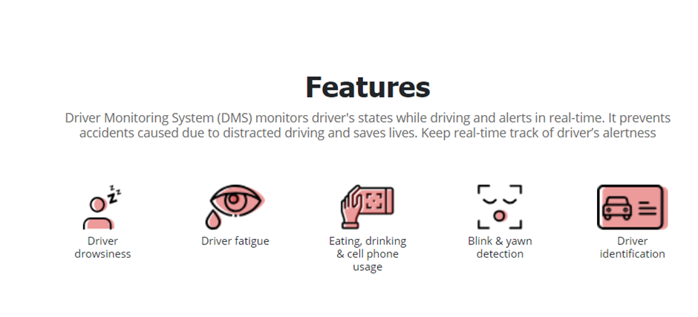

**Figure 1.1 Features of Driver State Sensing system**

**1.4. NOVELTY OF WORK**

* comparatively much cheaper and convenient
* very suitable and helpful for the Indian Population and preventing road accidents
* Eye Blinking and Yawn detection at night as well
* This paper proposes a low-cost and practical real-time driver monitoring and alert system in perspective to decrease the automobile accident rate not just in luxurious cars but in all of them.

**CHAPTER-2**

**LITERATURE SURVEY**

**2.1. LITERATURE SURVEY**

**2.1.1. THEORY ASSOCIATED WITH PROBLEM AREA**

A driver monitoring system is a blanket term for a system that uses AI to analyze driver behavior, primarily using the internal-facing camera.[2] Currently, the emphasis is on enforcing requirements such as wearing seatbelts or discouraging behaviors like looking at cellphones or tuning the radio while driving. The AI dash cams detect these actions' telltale patterns, issue an alert as a gentle reminder to the driver, and add a record in the driver logs.

**2.1.2. SAMPLE TABLE FOR LITERATURE SURVEY**

According to available statistical data, over 1.3 million people die each year on the road, and 20 to 50 million people suffer non-fatal injuries from road accidents [[1](https://www.ncbi.nlm.nih.gov/pmc/articles/PMC3571819/#b1-sensors-12-16937)]. Based on police reports, the US National Highway Traffic Safety Administration (NHTSA) conservatively estimated that a total of 100,000 vehicle crashes each year directly result from driver drowsiness. These crashes resulted in approximately 1,550 deaths, 71,000 injuries, and $12.5 billion in monetary losses [[2](https://www.ncbi.nlm.nih.gov/pmc/articles/PMC3571819/#b2-sensors-12-16937)]. In 2009, the US National Sleep Foundation (NSF) reported that 54% of adult drivers had driven a vehicle while feeling drowsy, and 28% had fallen asleep [[3](https://www.ncbi.nlm.nih.gov/pmc/articles/PMC3571819/#b3-sensors-12-16937)]. The German Road Safety Council (DVR) claims that one in four highway traffic fatalities results from momentary driver drowsiness [[4](https://www.ncbi.nlm.nih.gov/pmc/articles/PMC3571819/#b4-sensors-12-16937)]. These statistics suggest that driver drowsiness is one of the leading causes of road accidents.

A driver who falls asleep at the wheel loses control of the vehicle, often resulting in a crash with another car or stationary objects. To prevent these devastating accidents, the state of drowsiness of the driver should be monitored.

**Table 2.1 Sample table for literature survey**

|  |  |
| --- | --- |
| Blink frequency | The number of times an eye closes over a specific period |
| Maximum closure duration of the eyes | The maximum time the eye was closed. However, it can be risky to delay detecting an extended eye closure that indicates a drowsy driver. |
| Percentage of eyelid closure (PERCLOS) | The percentage of time (per minute) in which the eye is 80% closed or more. |
| Eye aspect ratio (EAR) | EAR reflects the eye’s openness degree. The EAR value drops down to zero when the eyes are closed. On the other hand, it remains approximately constant when the look is open. Thus, the EAR detects the eye closure at that time. |
| Yawning frequency | The number of times the mouth opens over a specific period. |
| A Head pose | It is a figure that describes the driver’s head movements. It is determined by counting the video segments that show a significant deviation of three Euler angles of head poses from their regular positions. These three angles are nodding, shaking, and tilting. |

**2.1.3. THE PROBLEM THAT HAS BEEN IDENTIFIED**

While on the road, the car is so powerful and in careless hands, it can be dangerous, and sometimes, that negligence can damage even the lives of people on the road. To monitor and prevent the harmful effects of such failure, many researchers have written research papers on the results of drowsiness. But sometimes, some points and observations the system makes are not accurate enough. Therefore, this project has been carried out to provide data and another perspective on the existing problem, improve its use and increase the solution.

**2.2. RESEARCH GAPS**

* The systematic reviews help to recognize what we know in the concerned domain.
* All the data gathered from primary studies is categorized.
* Once the systematic review of empirical studies is done, we gather relevant information and identify the research gaps in the existing research studies .
* The population of systematic review consists of research papers relevant to drowsiness detection.

**2.3. PROBLEM DEFINITION**

Fatigue is a security issue that any country in the world has not seriously addressed, primarily because of its nature. The best solution to this problem is probably to raise awareness of the dangers associated with fatigue and encourage motorists to acknowledge fatigue when needed.

The first is harder and more expensive to achieve, and the latter is impossible without a start as driving long hours is very rewarding. Money encourages drivers to make unwise decisions, such as driving all night long, even when tired. This is because drivers do not know about the great danger that comes with driving when they are tired.

Some countries have limited the hours a driver can drive in one place, but it is still not enough to solve this problem as its implementation is complicated and expensive.

**2.4. REQUIREMENT SPECIFICATION**

The requirements for an effective drowsy driver detection system are as follows:

1. A non-intrusive monitoring system that will not distract the driver.
2. A real-time monitoring system, to ensure accuracy in detecting drowsiness.
3. A system that will work in both daytime and nighttime conditions.

**2.4.1 INTRODUCTION**

Mobile phone usage has developed into a primary source of driver distraction as it induces drivers to carry their attention off-road, thus making vehicle occupants vulnerable to road crashes. Drowsiness-related crashes are more likely to occur during the early morning, mid-afternoon, and late at night. Many fatigue signs represent drowsy drivers, such as a driver repeatedly yawning, a driver having difficulty focusing or keeping their eyes open, and a driver having trouble keeping their head up.

Our project strives to assist drivers not only by enhancing their driving experience but also by taking into consideration overall passenger safety. This project has been implemented to provide data and other perspectives on the problem, improve its usability, and scale up solutions.

**2.4.1.1 PURPOSE**

People have been inventing machines and devising strategies to simplify and protect their lives, to perform routine tasks such as going to work, or for exciting purposes such as air travel. With the advent of technology, transportation systems continued to improve, and our reliance on them increased exponentially. It has deeply affected our lives as we know them. This project has been implemented to provide data and perspectives on the problem, improve its usability, and scale up solutions.

**2.4.1.2 INTENDED AUDIENCE AND READING SUGGESTION**

The intended audience of this document is the development team, project evaluation judge, and other tech-savvy enthusiasts who wish to continue the work on the project.

**2.4.1.3 PROJECT SCOPE**

Many products out there measure the fatigue level for drivers in most cars. Driver sleep detection system offers the same performance but with better results and additional benefits. Also, notify the user when they reach a certain point of whole drowsiness.

**2.4.2 OVERALL DESCRIPTION**

* Driver drowsiness detection is a car safety technology that helps prevent accidents caused by drivers getting drowsy. Various studies have suggested that around 20% of all road accidents are fatigue-related, up to 50% on certain roads.
* These can happen for multiple reasons, and we have tried to get possible solutions in this project.
* This project made us familiar with python programming.
* We dwelled on the concept of deep learning, neural networks, and various machine learning algorithms, for example, Viola jones’s algorithm.
* A low-cost application can be devised by implementing this system using the Arduino module.
* Worked with hardware components like a buzzer, webcam, and LEDs.
* Also, we understood how a team works together as we thrived on completing this project.
* To suggest ways to detect fatigue and drowsiness while driving.
* To study eyes and mouth from the video images of participants in the experiment of driving simulation conducted by MIROS that can be used as an indicator of fatigue and drowsiness.
* To investigate the physical changes of fatigue and drowsiness. Car safety technology if the driver gets drowsy. The yawning or wavering in the driver's body language is detected, and the alarm is activated [1].
* To develop a system that uses eye closure and yawning to detect fatigue and drowsiness. The driver's eye blinking estimate is done through the sensors in the camera. The video is acquired through a camera, which tells us about the eye blinking rate.

**2.4.2.1 PRODUCT PERSPECTIVE**

Driver fatigue their time requirement is a fraction of the previously used methods. The algorithm starts with the detection of heads on color pictures using deviations in ccolorand structure of the human face and that of the background. By normalizing the distance and position of the reference points, all faces should be transformed into the same size and position. For normalization, eyes serve as points of reference.

Another OpenCV algorithm finds the eyes on any grayscale image by searching for characteristic features of the eyes and eye sockets. Tests made on a standard database show that the algorithm works very fast and it is reliable. Here we will work with face detection. Initially, the algorithm needs a lot of positive images (images of faces) and negative images (images without faces) to train the classifier. Then we need to extract features from it. For this, OpenCV features shown in the below image are used. They are just like our convolutional kernel.

**2.4.3 EXTERNAL INTERFACE REQUIREMENT**

**2.4.3.1 SOFTWARE REQUIREMENTS**

**Python:**

• Python 3

**Libraries**

* NumPy
* SciPy
* Playsound
* Dlib
* Imutils
* Opencv, etc.

**Operating System**

* Windows or Ubuntu

**2.4.3.2 HARDWARE INTERFACE**

1. Laptop with basic hardware.

2. Dashcam

3. Sensors

4. Arduino UNO

**2.4.4 OTHER NON-FUNCTIONAL REQUIREMENTS**

a. Image processing is done using the captured video.

b. Image is stored in a library called OpenCV.

c. Stored image undergo various algorithm and detects if the driver is fatigue and if fatigue raises an alarm

**2.4.4.1 PERFORMANCE REQUIREMENTS**

* The project was developed to detect drowsiness and disturbance of the driver while driving a non-wheeled vehicle [3].
* Various project modules such as face detection, eye detection, face and eye tracking, drowsiness detection, and disturbance detection are all evaluated under unit and performance evaluation.
* Ineffective assessments such as stress, performance, or practical written information will not currently be assessed.
* Terms of suspension for this project are considered 50%, i.e., if 50% of test cases fail at any time, then the testing cycle is suspended.
* The way out is that 95% of test cases should be successful. We must achieve this success under low and good light conditions.

**2.5 APPROVED OBJECTIVES**

* **Driver gesture detection system**

Car safety technology if the driver gets drowsy. The yawning or wavering in the driver's body language is detected, and the alarm is activated.

* **Driver eye detection system**

The driver’s eye blinking estimate is done through the sensors in the camera. The video is acquired through a camera, which tells us about the eye blinking rate.

**2.6 PROJECT OUTCOMES AND DELIVERABLES**

We have used Open CV as a platform to develop a code for eye detection in real time. The code is then implemented on system installed with Open CV software. To detect human eyes, face has to be detected initially. This is done by OpenCV face haar cascade classifier. Once the face is detected, the location of the eyes is estimated and eye detection is done using eye Haar-cascade classifier. Hence using the openCV, face and eyes are detected accurately and displayed on the monitor. The larger yellow square indicates the face while small red squares indicate the eyes. Once face and eyes are detected, it is checking the status of eyes i.e. open or closed state of the eyes. If both eyes remain closed for successive frames, it indicates that the driver is drowsy and gives the warning signal. A webcam a video camera that feeds its image in real time to a computer or computer network. Unlike an IP camera (which uses a direct connection using Ethernet or Wi-Fi), a webcam is generally connected by a USB cable, FireWire cable, or similar cable. Their most popular use is the establishment of video links, permitting computers to act as videophones. The common use as a video camera for the World Wide Web gave the webcam its name. Other popular uses include security surveillance, computer vision, video broadcasting, and for recording social videos. A fatigue detection system based on the above method was implemented by using Visual C++. At first, we fix a camera on a car in front of the driver. Then we capture some videos from 8 drivers in normal conditions. The whole input image is in RGB color space. We have also found that the optimum distance from camera which obtained about 30cm-50cm that is very suitable for our method. Thus our eye detection method is robust and irrelevant with different sizes and more accurate. According to obtained results, our system can determine the eye states with a high rate of correct decision

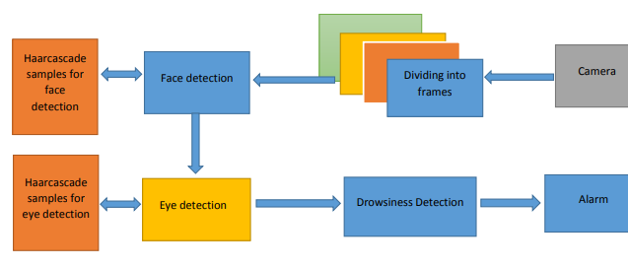

**Figure 2.1 Flowchart of proposed system**

**2.7. COST ANALYSIS**

The project requires various hardware devices to be able to be put into action. The various hardware components include Arduino uno, sensors, dashcam, wires, USB cables, etc. These are integrated with the software written in python (jupyter nb) on a PC windows 10. However, the products needed are low-budget equipment, making the project highly cost-efficient.

**TABLE 2.2 Cost analysis**

|  |  |
| --- | --- |
| Dashcam | 3500 |
| Arduino | 1000 |
| Ultrasonic sensor | 500 |
| Vibration motor | 300 |
| Buzzer, LEDs, Breadboard | 300 |

**2.8. RISK ANALYSIS**

1. **Dependence on ambient light**: – With poor lighting conditions even though face is easily detected, sometimes the system is unable to detect the eyes. So it gives an erroneous result which  
   must be taken care of. In real time scenario infrared backlights should be used to avoid poor lighting conditions.
2. **Optimum range required**: – when the distance between face and webcam is not at optimum range then cetain problems are arising. When face is too close to webcam(less than 30 cm), the system is unable to detect the face from the image. When face is away from the web cam (more than 70cm) then the backlight is insufficient to illuminate the face properly. So eyes are not detected with high accuracy which shows error in detection of drowsiness. This issue is not seriously taken into account as in real time scenario the distance between drivers face and webcam doesnt exceed 50cm. so the problem never arises.
3. **Hardware requirements**: – The system was run in a PC with a configuration of 1.6GHz and 1GB RAM Pentium dual core processor. Though the system runs fine on higher configurations, when a system has an inferior configuration, the system may not be smooth and drowsiness detection will be slow. The problem was resolved by using dedicated hardware in real time applications, so there are no issues of frame buffering or slower detection.
4. **Orientation of face**: – when the face is tilted to a certain extent it can be detected, but beyond this system fails to detect the face. So when the face is not detected, eyes are also not detected. This problem is resolved by using tracking functions that track any movement and rotation of the objects in an image.
5. **Poor detection with spectacles**: – When the driver wears glasses, the system fails to detect the eyes which are the most significant drawback of our system. This issue has not yet been resolved and is a challenge for almost all eye detection systems designed so far.
6. **Problem with multiple faces**: – If more than one face is detected by the webcam, then our

system gives an erroneous result. This problem is not important as we want to detect the drowsiness of a single driver.

**CHAPTER-3**

**FLOWCHART**

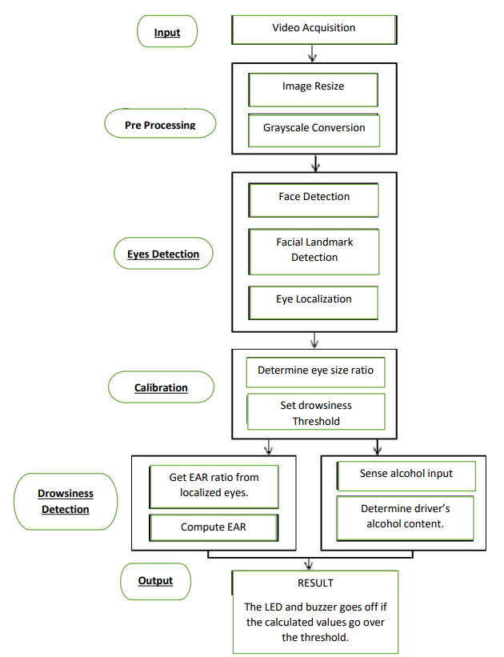

**Figure 3.1 Flowchart**

**3.1. SYSTEM ARCHITECTURE:**

This is the architecture for detecting the drowsiness of the driver. First, the system captures images through the webcam and then detects the face through the haar cascade algorithm. It uses haar features that can see the face. If the system finds it as a face, then it will proceed for next phase,e., eye detection. The eye is also detected using haar cascade features ,and it is used for blink frequency. The state of an eye will be seen using the perclos algorithm.

Through this algorithm, we can find the percentage of time the eyelids remain closed. If it considers eyes in a closed state, it detects the driver in a drowsy state and alerts him with an alarm. In some cases, distraction can be measured by continuous gazing. The driver's face is analyzed continuously to detect any distraction. If found then an alarm is activated by the system.

As drivers become drowsy, their head begins to sway and the vehicle may wander away from the center of the lane. The previously described vehicle-based and vision-based measures become apparent only after the driver starts to sleep, which is often too late to prevent an accident.

However, physiological signals start to change in earlier stages of drowsiness. Hence, physiological signals are more suitable to detect drowsiness with few false positives; making it possible to alert a drowsy driver in a timely manner and thereby prevent many road accidents.

* A drowsy person displays a number of characteristic facial movements, including rapid and constant blinking, nodding or swinging their head, and frequent yawning [[7](https://www.ncbi.nlm.nih.gov/pmc/articles/PMC3571819/#b7-sensors-12-16937)].
* Computerized, non-intrusive, behavioral approaches are widely used for determining the drowsiness level of drivers by measuring their abnormal behaviors [[12](https://www.ncbi.nlm.nih.gov/pmc/articles/PMC3571819/#b42-sensors-12-16937)].
* Most of the published studies on using behavioral approaches to determine drowsiness, focus on blinking [[13](https://www.ncbi.nlm.nih.gov/pmc/articles/PMC3571819/#b43-sensors-12-16937)–[15](https://www.ncbi.nlm.nih.gov/pmc/articles/PMC3571819/#b45-sensors-12-16937)].

**3.2. ANALYSIS**

The entire architecture is divided into 6 modules:

1. Face Detection

2. Eye Detection

3. Face Tracking

4. Eye Tracking

5. Drowsiness Detection

6. Distraction Detection

**Face Detection:**

This module takes input from the camera and tries to detect a face in the video input. The detection of the face is achieved through the Haar classifiers mainly, the Frontal face cascade classifier. The face is detected in a rectangle format and converted to grayscale image and stored in the memory which can be

used for training the model.

**Eye Detection:**

Since the model works on building a detection system for drowsiness we need to focus on the eyes to detect drowsiness. The eyes are detected through the video input by implementing a haar classifier namely Haar Cascade Eye Classifier. The eyes are detected in rectangular formats.

**Face Tracking:**

Due to the real-time nature of the project, we need to track the faces continuously for any form of distraction. Hence the faces are continuously detected during the entire time.

**Eye Tracking:**

The input to this module is taken from the previous module. The eye's state is determined through Perclos algorithm.

**Drowsiness detection:**

In the previous module the frequency is calculated and if it remains 0 for a longer period then the driver is alerted of the drowsiness through an alert from the system[2][4].

**Distraction detection:**

In the face tracking module, the face of the driver is continuously monitored for any frequent movements or the long gaze of the eyes without any blinks which can be treated as a lack of concentration of the driver, and is alerted by the system for distraction[6].

**3.3. TOOLS AND TECHNOLOGIES USED:**

**PYTHON -**

Python is an interpreted, high-level, general-purpose programming language. Python's design philosophy

emphasizes code readability with its notable use of significant whitespace. Its language constructs and object-oriented approach aim to help programmers write clear, logical code for small and large-scale projects. Python is dynamically typed AND supports multiple programming paradigms, including procedural, object-oriented, and functional programming.

**JUPYTER Lab -**

Project Jupyter is a nonprofit organization created to develop open-source software, open standards, and services for interactive computing across dozens of programming languages.

**IMAGE PROCESSING -**

In computer science, digital image processing is the use of computer algorithms to perform image processing on digital images.

**MACHINE LEARNING -**

Machine learning is the scientific study of algorithms and statistical models that computer systems use in order to perform a specific task effectively without using explicit instructions, relying on patterns and inference instead. It is seen as a subset of artificial intelligence. Machine learning algorithms build a mathematical model based on sample data, known as "training data", in order to make predictions or decisions without being explicitly told.

**CHAPTER-4**

**PROJECT DESIGN AND DESCRIPTION**

**4.1 DESCRIPTION**

A path to implementing our innovation idea in the form of the project named Driver State Sensing system. It is a safety system. The basic concept which emerges for our project is drunk driving detection, drowsiness detection, and gesture recognition. For the project, we have used dashcam, Arduino UNO, ultrasonic sensor. Drowsiness can be detected using the camera, we will use machine learning algorithms to identify facial features and alarm the driver using the buzzer. The GSM module sends the messages to the registered mobile number.

**4.2 U.G SUBJECTS**

* Machine Learning
* Image Processing
* Computer Vision
* Internet of Things

**4.3 STANDARDS USED**

* IEEE 610.4-1990 - IEEE Standard Glossary of Image Processing and Pattern Recognition Terminology
* IEEE 3652.1-2020 - IEEE Guide for Architectural Framework and Application of Federated Machine Learning
* IEEE Std 1451 series, addressing sensors (adopted by ISO/IEC)
* IEEE 802.11 standard, popularly known as Wi-Fi, lays down the architecture and specifications of wireless LANs (WLANs). WiFi or WLAN
* IEEE - P2413 - Standard for an Architectural Framework for the Internet of Things SCOPE.

**4.4. SURVEY OF TOOLS AND TECHNOLOGIES**

**4.4.1 ULTRASONIC SENSOR (HCSR04) COMPARISONS**

**4.4.1.1 ULTRASONIC SENSOR (HCSR04)**

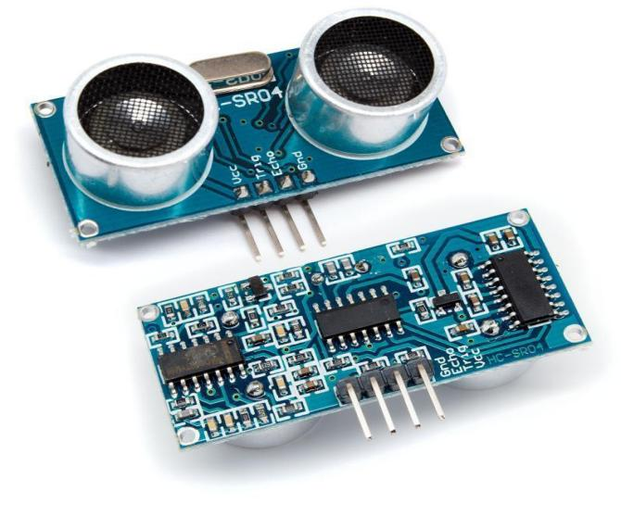

**Fig4.1 Ultrasonic sensor**

**4.4.1.2 WORKING PRINCIPLE**

The Ultrasonic HC-SR04 Sensor Module is a very popular sensor, it is used in many applications where measuring distance and detecting objects are required. It works on the same principle as a radar system. Ultrasonic sensors work by emitting high-frequency sound waves that are not heard by humans. It sends out a high-frequency sound pulse from the transmitter and then the receiver receives this sound when it reflects back from any object's surface. This way the sensors detect objects. It can measure distance or detect objects in the range of 2 cm-400 cm. The is comfortable with both microcontroller and microprocessor platforms like Arduino, ARM, PIC, Arduino , etc.[11]

**4.4.1.3 SPECIFICATIONS**

1. Input Voltage: 5V
2. Current Draw: 20mA (Max)
3. Digital Output: 5V
4. Digital Output: 0V (Low)
5. Working Temperature:  -15°C to 70°C
6. Sensing Angle: 30° Cone
7. Angle of Effect: 15° Cone
8. Ultrasonic Frequency: 40kHz

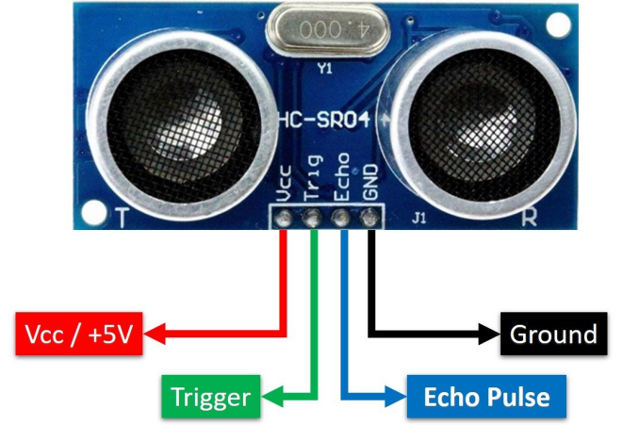

**Figure 4.2 Ultrasonic sensor Pin configuration**

**4.4.2 CAR DASH CAMERA COMPARISONS**

**4.4.2.1 CAR DASH CAMERA**

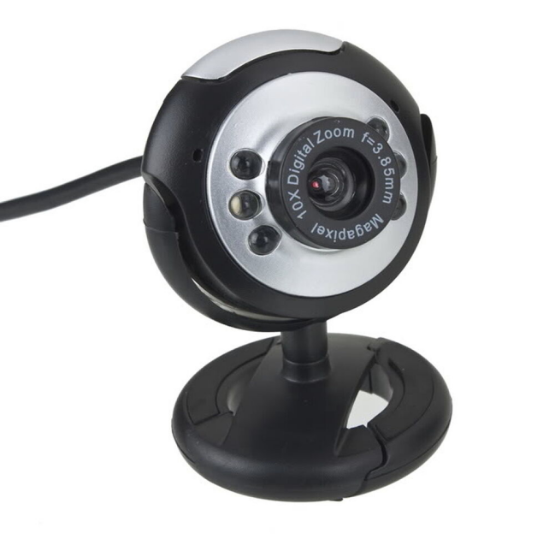

**Figure 4.3 Dash cam**

A video camera is used for monitoring the driver. The average blink rates in a human eye are between 10 to 22 blinks per minute and one blink lasts about 1/3 seconds. If the eye blink rate increases more than the threshold value it marks that the driver is sleepy or drowsy [5]. First, we will detect the face component and track the component to detect the drowsiness of the driver. If drowsiness is detected we will alert the driver through the alarm.

**4.4.2.2 WORKING PRINCIPLE**

The Arduino UNO, enclosed inside the Arduino casing, is being held by the adjustable GPS older - see Fig. 3(a). The adjustable GPS holder, shown in Fig. 3(b) allows the driver to adjust the position of the enclosed unit and is based on the sitting position (and height) of the driver accordingly, whether for a left-seat driver or a right-seat driver. The installed position of the camera module should avoid blocking the sight of the driver to ensure it could capture the driver’s face fully. The Arduino module is powered-up by the car adapter. When the system starts, it will collect the frontal scene as the HD stream- see Fig 4.4. Later, this video stream will be resized to 640×480 pixels with 30 frames per second encoded in H264 format, in grayscale.

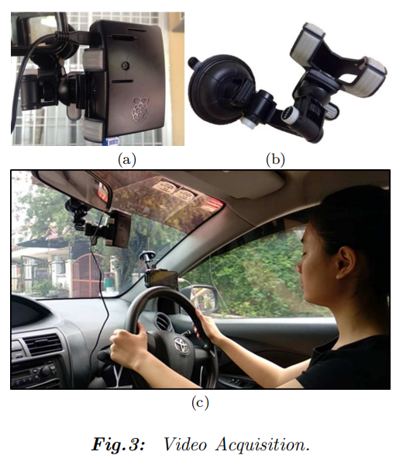

**Figure 4.4 Video Acquisition**

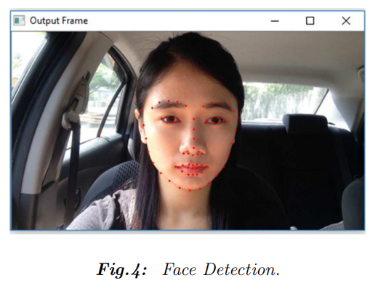

**Figure 4.5 Face Detection**

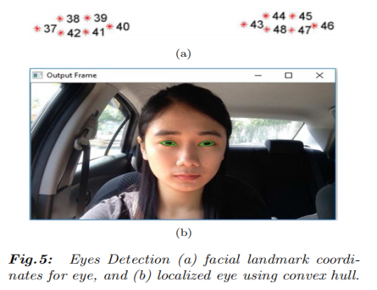

**Figure 4.6 Eyes detection**

1. **facial landmark coordinates of the eye**
2. **localized eye using convex hull**

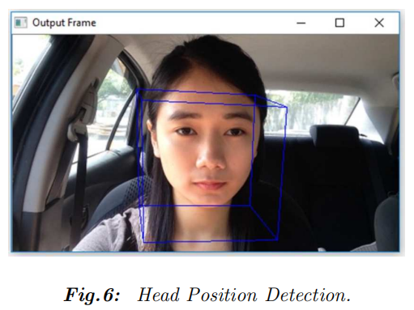

**Figure 4.7 Head position detection**

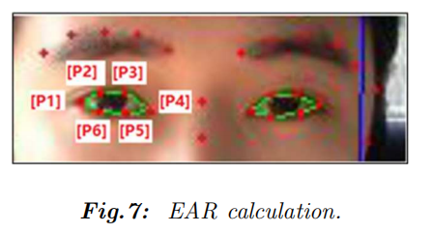

**Figure 4.8 EAR calculation**

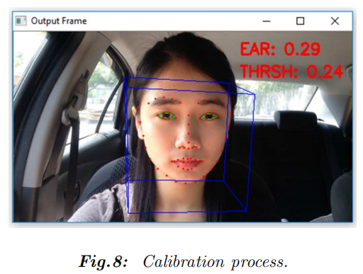

**Figure 4.9 Drowsiness detection**

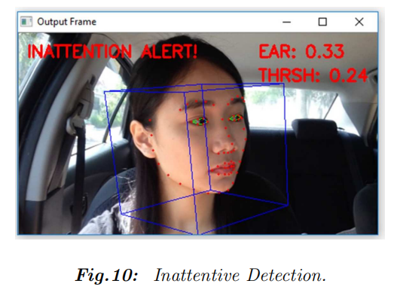

**Figure 4.10 Inattentive detection**

Thereafter, facial landmarks such as eyebrows, nose, mouth, eyes, and jawline were obtained. The eyes were then localized to calculate the PERCLOS [7], which is based on the Eye Aspect Ratio (EAR). The EAR was obtained once during the calibration period, at the system set-up time, which was used as the drowsiness threshold in the system. The drowsiness detection[8] and the inattentive detection works in parallel and an alarm will be triggered when either -

1. the EAR exceeds the drowsiness threshold[12]
2. the driver's head pose is not looking ahead. [6]

**4.4.2.3 SPECIFICATIONS**

1. Camera Type 1/2.7" CMOS
2. H/V Resolution 1920 x 1080
3. Output
4. Output 1080p30/25, 720p30/25, 960x540p30/25, 640x360p30
5. Compression H.264 SVC/AVC
6. Lens Focal Length f=3.5mm to 42.3mm
7. Lens F# 1.8-2.8
8. Zoom 12x optical
9. Focus Auto
10. Horizontal Field of View 6.9˚ - 72.5˚

**4.4.3 16 X 2 LCD DISPLAY COMPARISONS**

**4.4.3.1 16 X 2 LCD DISPLAY**

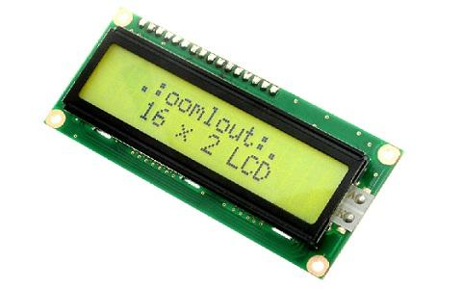

**Fig 4.11 LCD display**

The term [LCD stands for liquid crystal display](https://www.elprocus.com/difference-alphanumeric-display-and-customized-lcd/). It is one kind of electronic display module used in an extensive range of applications like various circuits & devices like mobile phones, calculators, computers, TV sets, etc. These displays are mainly preferred for multi-segment [light-emitting diodes](https://www.elprocus.com/light-emitting-diode-led-working-application/) and seven segments. The main benefits of using this module are inexpensive; simply programmable, animations, and there are no limitations for displaying custom characters, special and even animations, etc.

**4.4.3.2 WORKING PRINCIPLE**

Command register stores various commands given to the display. Data register stores data to be displayed. The process of controlling the display involves putting the data that form the image of what you want to display into the data registers, then putting instructions in the instruction register. In the project [Liquid Crystal Library](https://www.arduino.cc/en/Reference/LiquidCrystal) simplifies this for you so you don't need to know the low-level instructions. Contrast of the display can be adjusted by adjusting the potentiometer to be connected across VEE pin.

**4.4.3.3 SPECIFICATIONS**

* The operating voltage of this LCD is 4.7V-5.3V
* It includes two rows where each row can produce 16-characters.
* The utilization of current is 1mA with no backlight
* Every character can be built with a 5×8 pixel box
* The alphanumeric LCDs alphabets & numbers
* Is display can work on two modes like 4-bit & 8-bit
* These are obtainable in Blue & Green Backlight
* It displays a few custom generated characters

**4.4.4 MULTIMEDIA SPEAKER COMPARISONS**

**4.4.4.1 EPHEMERAL MULTIMEDIA SPEAKER**

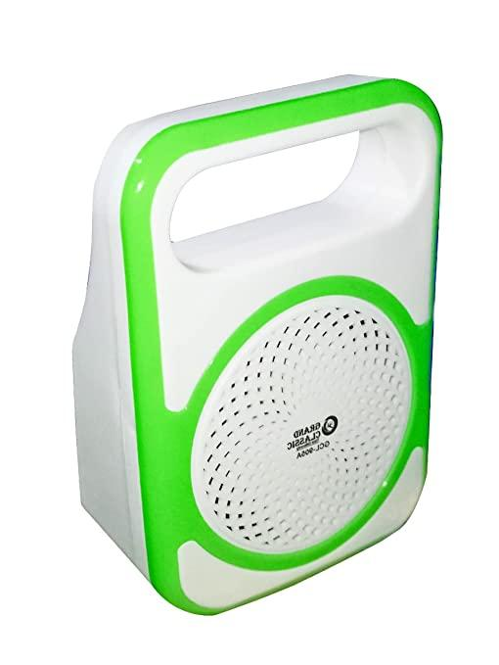

**Fig 4.12 Speaker**

EPHEMERAL High-Quality Sound Output, these 1 speakers are small in size, but offer impressive sound output. Despite their compact design, they deliver loud, crystal clear sound. These travel speakers produce low, deep bass that is extremely pleasing to the ear. These Ephemeral black compact speakers are magnetically shielded to prevent sound distortions, frequency glitches and to prevent friction against other magnetic devices. Easy to Connect to External Devices these 2.0 compact speakers are compatible with a number of digital devices like your smartphones, laptops, PCs, and music players.

**4.4.4.2 WORKING PRINCIPLE**

Speakers work by converting electrical energy into mechanical energy (motion). The mechanical energy compresses air and converts the motion into sound energy or sound pressure level (SPL). When an electric current is sent through a coil of wire, it induces a magnetic field. In speakers, a current is sent through the voice coil which produces an electric field that interacts with the magnetic field of the permanent magnet attached to the speaker. Like charges repel each other and different charges attract. As an audio signal is sent through the voice coil and the musical waveform moves up and down, the voice coil is attracted and repelled by the permanent magnet. This makes the cone that the voice coil is attached to move back and forth. The back and forth motion creates pressure waves in the air that we perceive as sound

**4.4.4.3 SPECIFICATIONS**

**Table 4.1 Specifications of speaker**

|  |  |
| --- | --- |
| Item Dimensions LxWxH | 20 x 10 x 2 Millimeters |
| Item Weight | ‎200 g |

**4.4.5 BUZZER COMPARISONS**

**4.4.5.1 BUZZER**

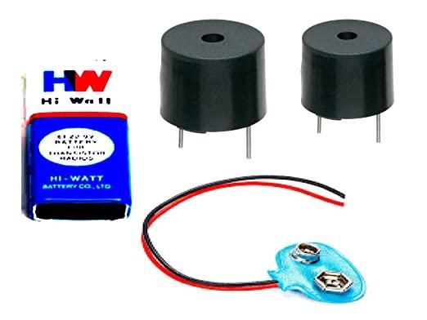

**Fig. 4.13 Buzzer**

An audio signaling device like a beeper or buzzer may be electromechanical or [piezoelectric](https://www.elprocus.com/what-is-a-piezoelectric-material-working/) or mechanical type. The main function of this is to convert the signal from audio to sound. Generally, it is powered through DC voltage and used in timers, alarm devices, printers, alarms, computers, etc. Based on the various designs, it can generate different sounds like alarm, music, bell & siren.

**4.4.5.2 WORKING PRINCIPLE**

It includes two pins namely positive and negative. The positive terminal of this is represented with the ‘+’ symbol or a longer terminal. This terminal is powered through 6Volts whereas the negative terminal is represented with the ‘-‘symbol or short terminal and it is connected to the GND terminal. Once the voltage is given across a piezoelectric material, then a pressure difference is produced. A piezo type includes piezo crystals among two conductors. Once a potential disparity is given across these crystals, then they thrust one [conductor](https://www.elprocus.com/what-is-an-acsr-conductor-types-and-its-advantages/) & drag the additional conductor through their internal property. So this continuous action will produce a sharp sound signal.

**4.4.5.3 SPECIFICATIONS**

The specifications of the buzzer include the following.

* The frequency range is 3,300Hz
* Operating Temperature ranges from – 20° C to +60°C
* Operating voltage ranges from 3V to 24V DC
* The sound pressure level is 85dBA or 10cm
* The supply current is below 15mA

**4.4.6 ENGINE MOTOR COMPARISONS**

**4.4.6.1. ENGINE MOTOR**

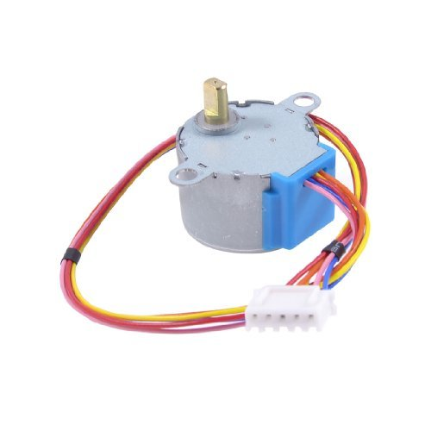

**Fig 4.14 Engine motor**

Stepper motor is an actuator transforming electric pulse into angular displacement. Popularly, when receiving a pulse signal, the stepper motor will rotate a fixed angle (namely "stepping angle") according to the direction set for the stepper motor. The angular displacement volume can be controlled by controlling the pulse number to achieve the purpose of positioning accurately. In the meantime, the rotational velocity and acceleration of the motor can be controlled by controlling the pulse frequency to achieve the purpose of speed control.

**4.4.6.2 WORKING PRINCIPLE**

The stepper motor rotor is a permanent magnet, when the current flows through the stator winding, the stator winding to produce a vector magnetic field. The magnetic field drives the rotor to rotate by an angle so that the pair of magnetic fields of the rotor and the magnetic field direction of the stator are consistent. When the stator's vector magnetic field is rotated by an angle, the rotor also rotates with the magnetic field at an angle. Each time an electrical pulse is input, the motor rotates one degree further. The angular displacement it outputs is proportional to the number of pulses input and the speed is proportional to the pulse frequency. Change the order of winding power, the motor will reverse. Therefore, it can control the rotation of the stepping motor by controlling the number of pulses, the frequency and the electrical sequence of each phase winding of the motor.

**4.4.6.3 SPECIFICATIONS**

**Table 4.2 Specifications of engine motor**

|  |  |
| --- | --- |
| Drive system: | Unipolar |
| Step angle: | 1.8° full step  0.9° half-step |
| Phase/Windings: | 4/2 |
| Voltage & Current: | 12V at 400 mA |
| Resistance per Phase: | 30 ohms |
| Inductance per Phase: | 23 mH |
| Insulation resistance: | >100 MΩ at 500VDC |

**4.4.7 VIBRATION MOTOR COMPARISONS**

**4.4.7.1. VIBRATION MOTOR**

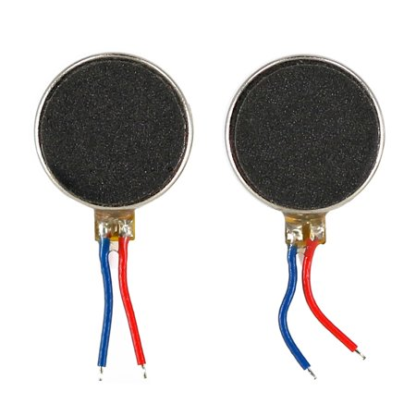

**Fig 4.15 Vibration motor**

Vibrator Motors are the mechanical devices used to develop vibrations. The generation of vibration has happened with the support of an [electric](https://www.watelectrical.com/what-is-electrical-conductivity-working-principle-formula-applications/) motor having an inequitable mass on its driveshaft. It is a miniature sized DC motor that lets the user know the sound through vibrations. The foremost feature that has to be noted in this is its magnet coreless DC motor which is permanent where it means that it possesses magnetic properties (performs like a magnet only when the electric current is passed through the device).

**4.4.7.2 WORKING PRINCIPLE**

A Coin or flat-sized motor works with the help of ring magnet, power supplied brushes connected to ring magnet, weight and a rotor with the commutation points connected at the front side and the coils connected on the backside. The commutation points and the brushes end are connected together.

This construction will strengthen the rotor electrical coils. This will generate a magnetic field, and this is as much as necessary to interrelate with the ring magnet and causes rotation. A force is produced because of a magnetic field. This force allows the weight to get transferred. The continual movement of weight generates a changing force so that it is felt as a vibration. The commutation points are utilized in altering the polarity pairs; thus, the rotor rotates, and the coils are perpetually switching the polarity.

**4.4.7.3 SPECIFICATIONS**

**Table 4.3 Specifications of vibration motor**

|  |  |  |
| --- | --- | --- |
| Specification | Value | Measured in |
| Operating Voltage | 3 | V |
| Frame Diameter | 10 | mm |
| Body Length | 3.4 | mm |
| Voltage Range | 2.5 – 3.8 | V |
| Start Voltage | 2.3 | V |
| Weight | 1.2 | g |
| Rated Current | 75 | mA |
| Rated Speed | 12000 | rpm |
| Start Current | 85 | mA |
| Vibration Amplitude | 0.8 | G |

**4.4.8 AMPLIFIER COMPARISONS**

**4.4.8.1. AMPLIFIER (PAM8403)**

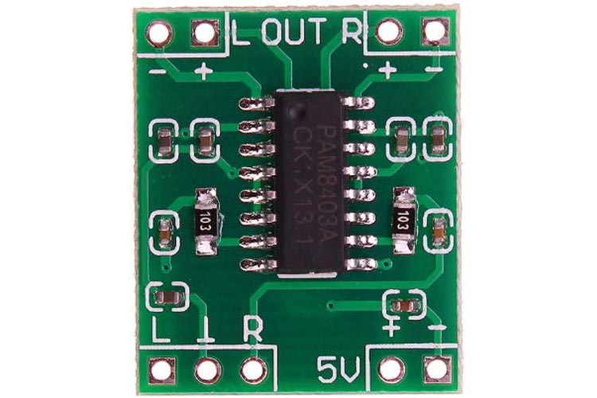

**Fig 4.16 Amplifier**

The PAM8403 is a 2-channel, 3W, class-D audio amplifier module that features low harmonic distortion and high efficiency. It offers low THD+N, allowing it to achieve high-quality sound reproduction. Operating voltage for this module range from 2.5 V to 5.5 V, making it ideal for adding the audio capability to your MP3 and MP4 player projects.

**Table 4.4 Specifications of amplifier**

|  |  |  |
| --- | --- | --- |
| Pin No. | Pin Name | Description |
| 1 | +OUT_L | Left Channel Positive Output |
| 2 | -OUT_L | Left Channel Negative Output |
| 3 | INL | Left Channel Input |
| 4 | INR | Right Channel Input |
| 5 | -OUT_R | Right Channel Negative Output |
| 6 | +OUT_R | Right Channel Positive Output |
| 7 | 5V | Positive Supply |
| 8 | GND | Ground Pin |

**4.4.8.2 WORKING PRINCIPLE**

The PAM8403 is a 2-channel, 3W, class-D audio amplifier. The internal circuit diagram of the PAM8403 Module is shown below. The new filterless architecture allows the device to drive the speaker directly, requiring no low-pass output filters. With the same numbers of external components, the efficiency of the PAM8403 is much better than that of Class-AB cousins. As shown in circuit diagram output speakers connects to ± OUT_L and ± OUT_R directly. INL and INR pins are used for left and right channel input. These pins are connected through a 0.47µf ceramic capacitor to reduce noise caused by the power supply coupling into the output drive signal. The recommended operating voltage for PAM8403 is 5.5V.

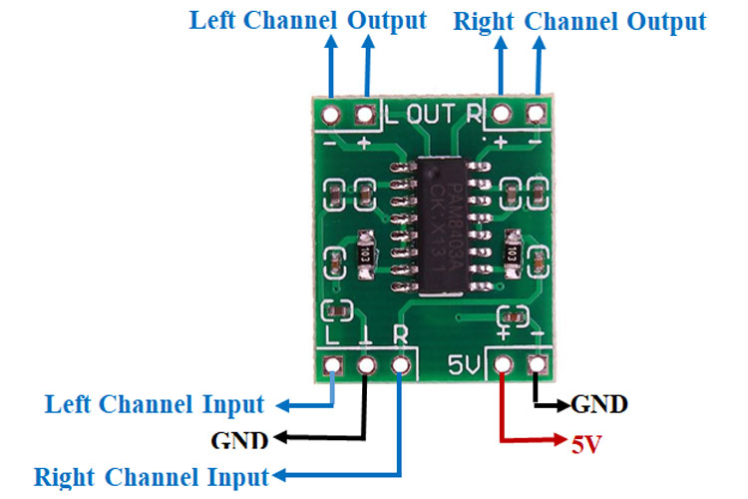

**Fig 4.17 Amplifier working**

**4.4.8.3 SPECIFICATIONS**

* 2 channels 3 W PAM8403 audio amplifier
* Output Power: 3 W + 3 W (at 4 ohm)
* Working Voltage: 2.5 to 5.5 V
* Board Size: 24 x 15 mm
* High amplification efficiency 85%
* Unique without LC filter class D digital power board
* Can use computer USB power supply directly

**4.4.9 ARDUINO UNO COMPARISONS**

**4.4.9.1. ARDUINO UNO**

The Arduino Uno is an [open-source](https://en.wikipedia.org/wiki/Open-source) [microcontroller board](https://en.wikipedia.org/wiki/Microcontroller_board) based on the [Microchip](https://en.wikipedia.org/wiki/Microchip_Technology) [ATmega328P](https://en.wikipedia.org/wiki/ATmega328P) microcontroller and developed by [Arduino.cc](https://en.wikipedia.org/wiki/Arduino) and initially released in 2010.[[22]](https://en.wikipedia.org/wiki/Arduino_Uno#cite_note-2)[[23]](https://en.wikipedia.org/wiki/Arduino_Uno#cite_note-What_is_Arduino?-3) The board is equipped with sets of digital and analog [input/output](https://en.wikipedia.org/wiki/Input/output) (I/O) pins that may be interfaced to various [expansion boards](https://en.wikipedia.org/wiki/Expansion_board) (shields) and other circuits.[[21]](https://en.wikipedia.org/wiki/Arduino_Uno#cite_note-Makerspace-1) The board has 14 digital I/O pins (six capable of [PWM](https://en.wikipedia.org/wiki/Pulse-width_modulation) output), 6 analog I/O pins, and is programmable with the [Arduino IDE](https://en.wikipedia.org/wiki/Arduino#Software) (Integrated Development Environment), via a type B [USB cable](https://en.wikipedia.org/wiki/USB_cable).[[24]](https://en.wikipedia.org/wiki/Arduino_Uno#cite_note-princeton-4) It can be powered by the USB cable or by an external [9-volt battery](https://en.wikipedia.org/wiki/9-volt_battery), though it accepts voltages between 7 and 20 volts.

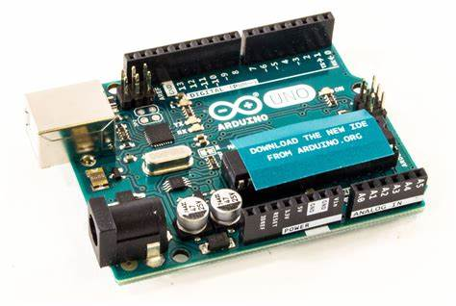

**Fig 4.18 Arduino UNO**

It is similar to the [Arduino Nano](https://en.wikipedia.org/wiki/Arduino_Nano) and Leonardo.[[25]](https://en.wikipedia.org/wiki/Arduino_Uno#cite_note-5)[[26]](https://en.wikipedia.org/wiki/Arduino_Uno#cite_note-6) The hardware reference design is distributed under a [Creative Commons](https://en.wikipedia.org/wiki/Creative_Commons) Attribution Share-Alike 2.5 license and is available on the Arduino website. Layout and production files for some versions of the hardware are also available. The Uno board is the first in a series of USB-based Arduino boards;[[23]](https://en.wikipedia.org/wiki/Arduino_Uno#cite_note-What_is_Arduino?-3) it and version 1.0 of the Arduino [IDE](https://en.wikipedia.org/wiki/Integrated_development_environment) were the reference versions of Arduino, which have now evolved to newer releases.[[24]](https://en.wikipedia.org/wiki/Arduino_Uno#cite_note-princeton-4) The ATmega328 on the board comes preprogrammed with a [bootloader](https://en.wikipedia.org/wiki/Bootloader) that allows uploading new code to it without the use of an external hardware programmer.[[23]](https://en.wikipedia.org/wiki/Arduino_Uno#cite_note-What_is_Arduino?-3)

While the Uno communicates using the original STK500 protocol,[[21]](https://en.wikipedia.org/wiki/Arduino_Uno#cite_note-Makerspace-1) it differs from all preceding boards in that it does not use the FTDI USB-to-serial driver chip. Instead, it uses the Atmega16U2 (Atmega8U2 up to version R2) programmed as a [USB-to-serial converter](https://en.wikipedia.org/wiki/USB-to-serial_converter).[[27]](https://en.wikipedia.org/wiki/Arduino_Uno#cite_note-website-7)

**4.4.9.2 WORKING PRINCIPLE**

The Arduino is a board based on an ATMEL AVR microcontroller. Microcontrollers are integrated circuits where instructions can be recorded , which you write with the programming language that you can use in the Arduino IDE environment. These instructions allow you to create programs that interact with the circuitry on the board. The most used microcontrollers on Arduino platforms are the [Atmega168](http://www.atmel.com/devices/atmega168.aspx), [Atmega328,](http://www.atmel.com/devices/atmega328.aspx) [Atmega1280](http://www.atmel.com/devices/atmega2560.aspx), [ATmega8](http://www.atmel.com/devices/ATMEGA8.aspx) for their simplicity, but it is being expanded to Atmel microcontrollers with 32-bit ARM architecture and also to Intel microcontrollers.

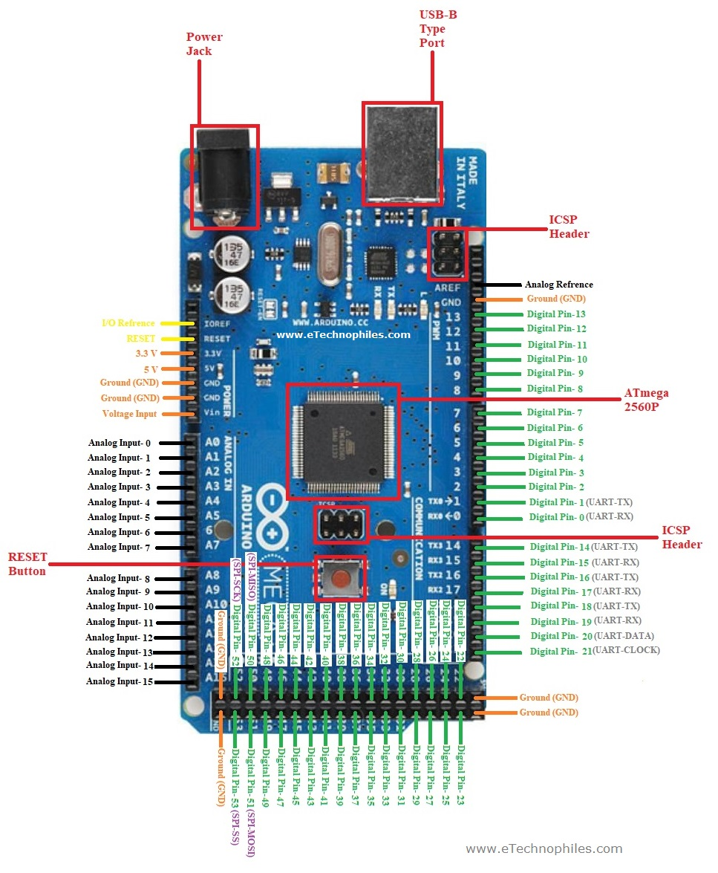

**Fig 4.19 Arduino UNO Pinout**

The Arduino microcontroller has communication ports and input / output ports. with which we can connect different types of peripherals on the board. The information of these peripherals that you connect will be transferred to the microcontroller, which will be in charge of processing the data that comes through them. On the other hand, Arduino provides us with software consisting of a development environment [(IDE)](https://en.wikipedia.org/wiki/Integrated_development_environment) that implements the arduino programming language, the tools to transfer the firmware to the microcontroller and the bootloader executed on the board. The main feature of the software and the programming language is its simplicity and ease of use.

Arduino promises to be a simple way to carry out interactive projects for anyone. For someone who wants to do a project, the process is to download and install the IDE, search the internet a bit and simply “cut and paste” the code that interests us and upload it to our HW. Then make the corresponding wiring with the peripherals and we already have the software interacting with the Hardware. All this with a minimal economic investment: the cost of the Arduino and the peripherals.

**4.4.9.3 SPECIFICATIONS**

**Table 4.5 Specifications of Arduino**

|  |  |
| --- | --- |
| Microcontroller | AT91SAM3X8E |
| Operating Voltage | 3.3V |
| Input Voltage (recommended) | 7-12V |
| Input Voltage (limits) | 6-20V |
| Digital I/O Pins | 54 (of which 12 provide PWM output) |
| Analog Input Pins | 12 |
| Analog Outputs Pins | 2 (DAC) |
| Total DC Output Current on all I/O lines | 130 mA |
| DC Current for 3.3V Pin | 800 mA |
| DC Current for 5V Pin | 800 mA |
| Flash Memory | 512 KB all available for the user applications |

**CHAPTER-5**

**IMPLEMENTATION & EXPERIMENTAL RESULT**

**5.1 CIRCUIT STIMULATION**

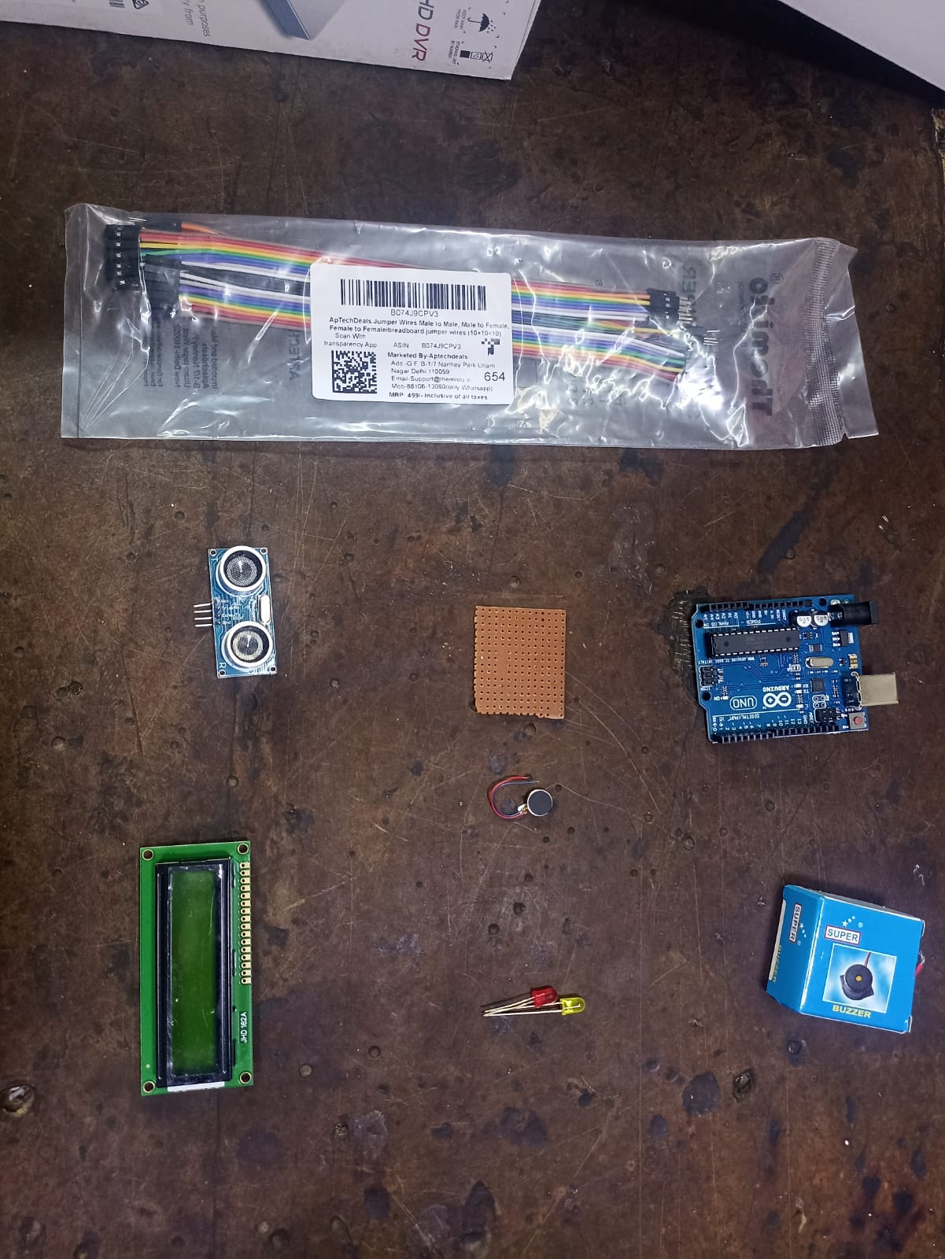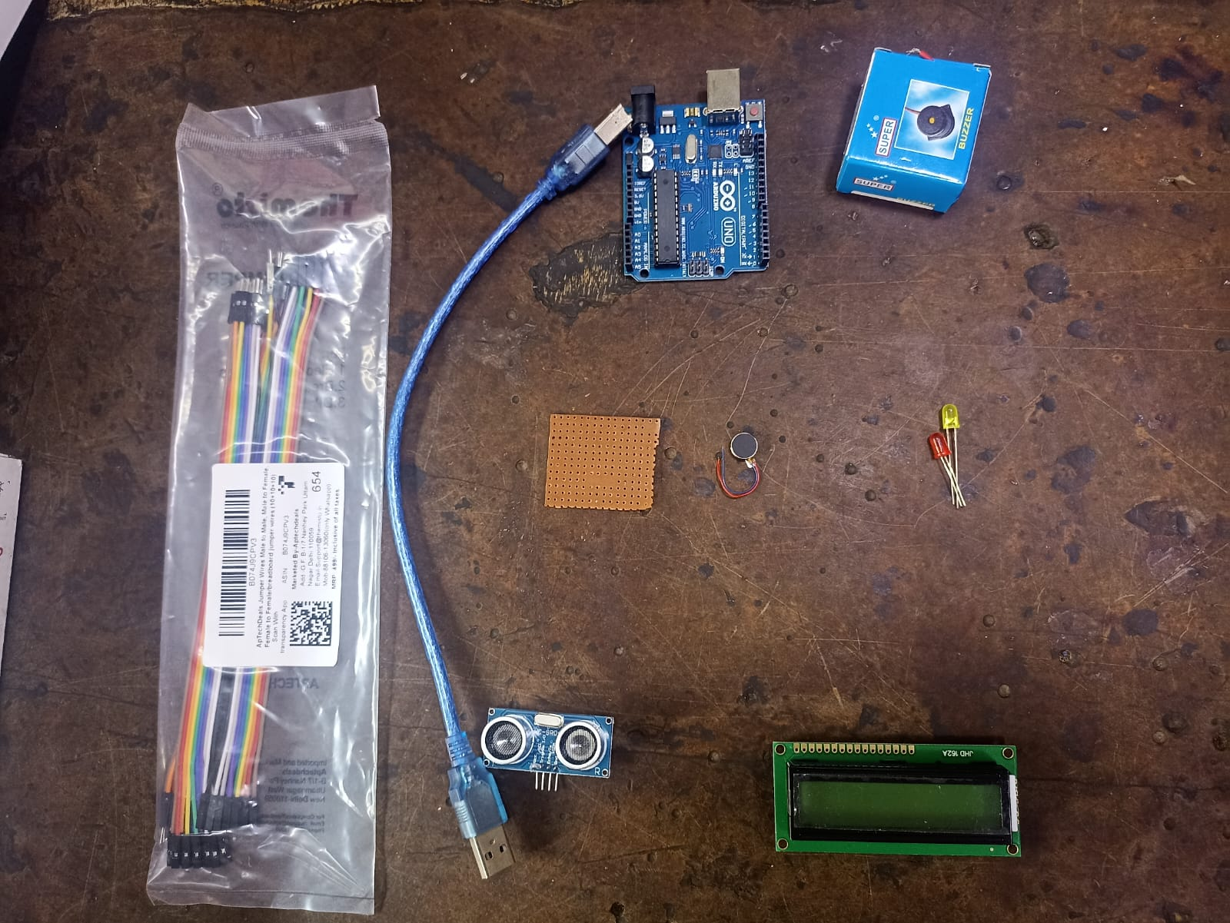

**Fig 5.1 Circuit components**

**5.1.2 DISTRACTION DETECTION SIMULATION**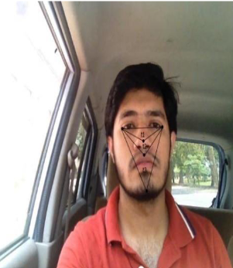 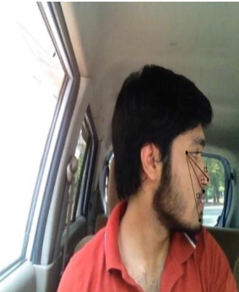

**Fig 5.2 Distraction detection simulation**

**5.1.3 YAWN DETECTION SIMULATION**

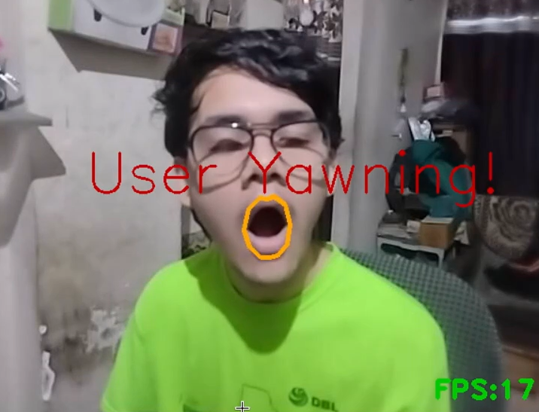

**Fig 5.3 Yawn detection simulation**

**5.1.1 ULTRASONIC SENSOR SIMULATION**

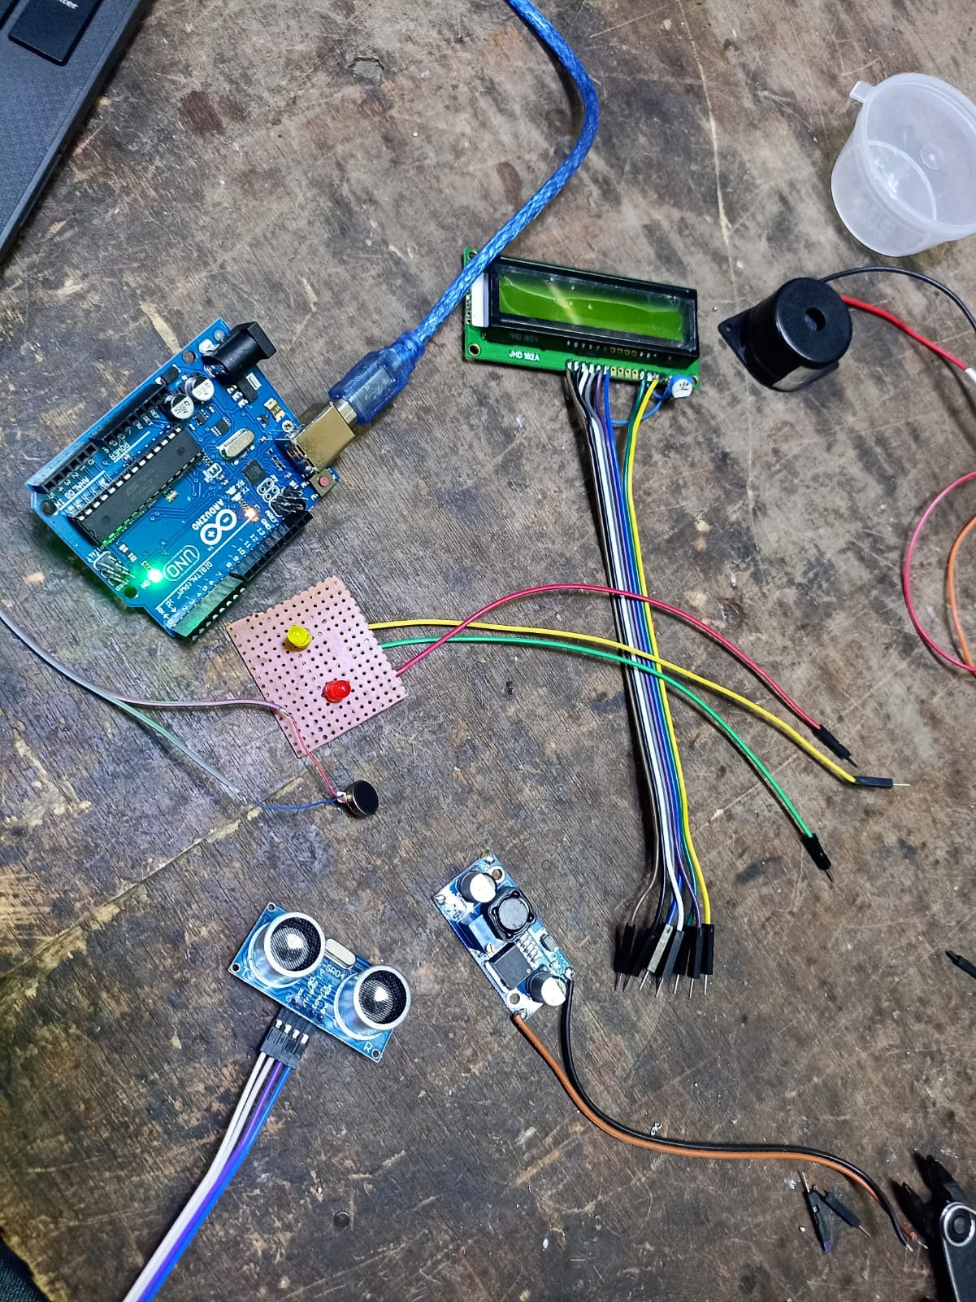

**Fig 5.4 Ultrasonic sensor simulation**

**5.2 PYTHON CODE SIMULATION**

import cv2

from utils import predict_is_eye_open, speak

from Serial import SerialData

face = cv2.CascadeClassifier(

'haar cascade files\haarcascade_frontalface_alt.xml')

leye = cv2.CascadeClassifier(

'haar cascade files\haarcascade_lefteye_2splits.xml')

reye = cv2.CascadeClassifier(

'haar cascade files\haarcascade_righteye_2splits.xml')

eye_raw_data = {

"open": {

"color": (0, 255, 0),

"msg": "Eye Open",

"status": " Active "

},

"close": {

"color": (0, 0, 255),

"msg": "Eye Closed",

"status": " In Active "

}

}

#the code that is uncomment that is serial data rx/tx

#uncomment when connected to hardware

# un commment the lines with # ---> 👍👍👍👍

# serial = SerialData() # --->

cap = cv2.VideoCapture(0, cv2.CAP_DSHOW)

count = 10

speak("Welcome to Driver Drowsiness Detection")

while True:

ret, frame = cap.read()

if not ret:

continue

height, width = frame.shape[:2]

gray = cv2.cvtColor(frame, cv2.COLOR_BGR2GRAY)

faces = face.detectMultiScale(

gray, minNeighbors=5, scaleFactor=1.1, minSize=(25, 25))

left_eye = leye.detectMultiScale(gray)

right_eye = reye.detectMultiScale(gray)

frame, left_eye_status = predict_is_eye_open(left_eye, frame)

frame, right_eye_status = predict_is_eye_open(right_eye, frame)

serial_data={}

# serial_data = serial.read() # --->

if left_eye_status and right_eye_status:

data = eye_raw_data["open"]

if count < 10:

count += 1

else:

data = eye_raw_data["close"]

if count > 0:

count -= 1

for (x, y, w, h) in faces:

cv2.rectangle(frame, (x, y), (x+w, y+h), (100, 100, 100), 1)

cv2.rectangle(frame, (x, y), (x+w, y+h), data["color"], 2)

cv2.rectangle(frame, (x, y-40), (x+w, y), data["color"], cv2.FILLED)

cv2.putText(frame, data["msg"], (x, y-10),

cv2.FONT_HERSHEY_SIMPLEX, 0.8, (255, 255, 255), 2)

break

cv2.rectangle(frame, (0, height-50), (width, height),

(0, 0, 0), thickness=cv2.FILLED)

cv2.putText(frame, data["status"], (10, height-20),

cv2.FONT_HERSHEY_COMPLEX_SMALL, 1, (255, 255, 255), 1, cv2.LINE_AA)

if serial_data.get("D") is not None:

cv2.putText(frame, "Distance : {} cm".format(serial_data["D"]), (width-250, height-20),

cv2.FONT_HERSHEY_COMPLEX_SMALL, 1, (255, 255, 255), 1, cv2.LINE_AA)

cv2.imshow('Real-Time Drowsiness Detection', frame)

if serial_data.get("O") is not None and serial_data.get("O") == '1':

speak("Obstacle Detected")

# if count == 0: # ---> serial.write('n') # --->

# elif count == 10: # ---> serial.write('y') # --->

if cv2.waitKey(1) & 0xFF == ord('q'):

break

cap.release()

cv2.destroyAllWindows()

**5.2.1 FLOW CHART OF CODE APPROACH**

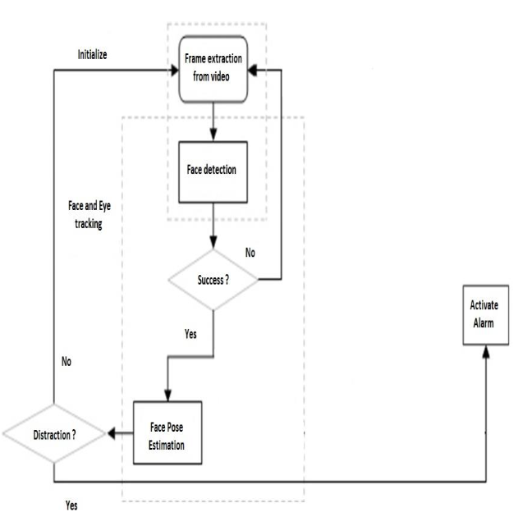

**Fig 5.5 Flowchart of code approach**

**5.2.2 FUNCTIONS USED IN THE CODE**

* Cv2
* Cv2.cascadeclassifier
* Cv2.cvtColor
* Cv2.cascadeclassifier
* Cv2.cvtColor
* Cv2.rectangle
* Cv2.putText
* Cv2.imshow
* Cv2.waitKey
* Utils
  + - Predict_is_eye_open.speak
* Serial
* Serial data
* Eye_raw_data

**CHAPTER-6**

**OUTCOME AND PROSPECTIVE LEARNING**

**6.1 SCOPE AND OUTCOMES**

The future work may focus on the utilization of outer factors such as vehicle states, sleeping hours, weather conditions, mechanical data, etc, for fatigue measurement. The purpose of the drowsiness detection system is to aid in the prevention of accidents passenger and commercial vehicles. This system can be further extended to have security like only certain people can access the vehicle. In case of theft, the vehicle does not start and an mms of the burglar could be sent to the owner of the vehicle.

The system will detect the early symptoms of drowsiness before the driver has fully lost all attentiveness and warn the driver that they are no longer capable of operating the vehicle safely.Moving forward, there are a few things we can do to further improve our results and fine-tune the models. First, we need to incorporate distance between the facial landmarks to account for any movement by the subject in the video.

Realistically the participants will not be static on the screen and we believe sudden movements by the participant may signal drowsiness or waking up from micro-sleep. Second, we want to update parameters with our more complex models (NNs, ensembles, etc.) in order to achieve better results. Third and finally, we would like to collect our own training data from a larger sample of participants (more data!!!) while including new distinct signals of drowsiness like sudden head movement, hand movement, or even tracking eye movements.

**6.2 PROSPECTIVE LEARNINGS**

We learned quite a few things throughout this project. First, simpler models can be just as efficient at completing tasks as more complex models. Normalization was crucial to our performance.

We recognized that everybody has a different baseline for eye and mouth aspect ratios and normalizing for each participant was necessary. Outside of runtime for our models, data pre-processing and feature extraction/normalization took up a bulk of our time. It will be interesting to update our project and look into how we can decrease the false-negative rate for kNN and other simpler models.

**6.3 CONCLUSION :**

In this paper, two different implementations for a driver drowsiness detection system are proposed, where deep learning plays an important role. These systems use images of the driver to identify fatigue symptoms, but instead of predicting whether a driver is tired or not from a single image, in this work, a full sequence of 60 s is used to determine whether the driver is tired or not over the last minute. The first solution proposed uses a model based on deep learning for the estimation of the drowsiness level of the driver, using a combination of a convolutional neural network with a recurrent neural network.

The second solution uses fuzzy logic for calculating the fatigue but needs to apply artificial intelligence and deep learning techniques to preprocess the data before using the fuzzy inference system. Testing was performed using a 5-fold cross-validation on 122 videos that have a duration of approximately 10 min per recording, which are provided by the UTA-database. The number of raised alarms was counted for each video, verifying in this way whether the system is reliable or not. Neither of the systems reported a satisfying performance, both of them obtaining an accuracy of around 65% over training data and over 60% on test data. However, the second alternative, which combines deep learning with fuzzy logic, reported promising results.

This system is able to work continuously without bothering the driver when he or she is not drowsy, since among the 60 videos of attentive drivers, there was only one video in which the system raised an alarm incorrectly (raising an unnecessary alarm only in 7% of the cases where the driver was actually alert). This way ,the minimization of the false positive rate obtained is considered a success. Its accuracy when correctly detecting the drowsiness of the driver, however, needs to be improved, because the system alerted the driver only in approximately 22 out of61 videos where the subjects were drowsy (36% accuracy).

This means that, although the conditions established for the fuzzy system are related to fatigue symptoms and can be used to detect fatigue, they do not represent all of the possible symptoms and thus cannot detect drowsiness on all videos. Both systems have great potential, and multiple ways of improving them were identified and will be addressed in the future. Detecting drowsiness from images of the driver is a complex problem that even commercial automotive brands struggle with. Further Investigation will be needed before completion, for which this work stands as a solid baseline to improve upon.

**CHAPTER-7**

**PROJECT TIMELINE**

**7.1. WORK BREAKDOWN**

**Table 7.1 Division of work**

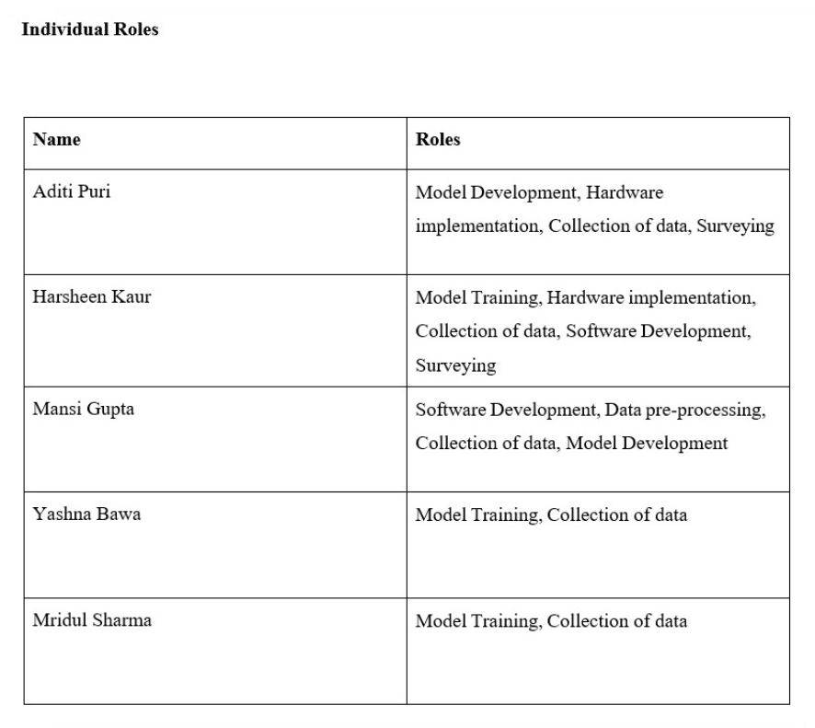

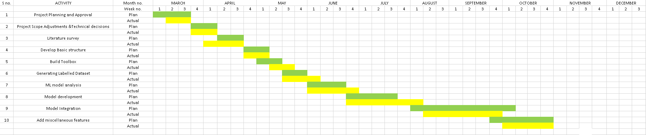**7.2. GANTT CHART**

**Figure 7.1 Gantt chart**

**7.3 INDIVIDUALGANTT CHARTS**

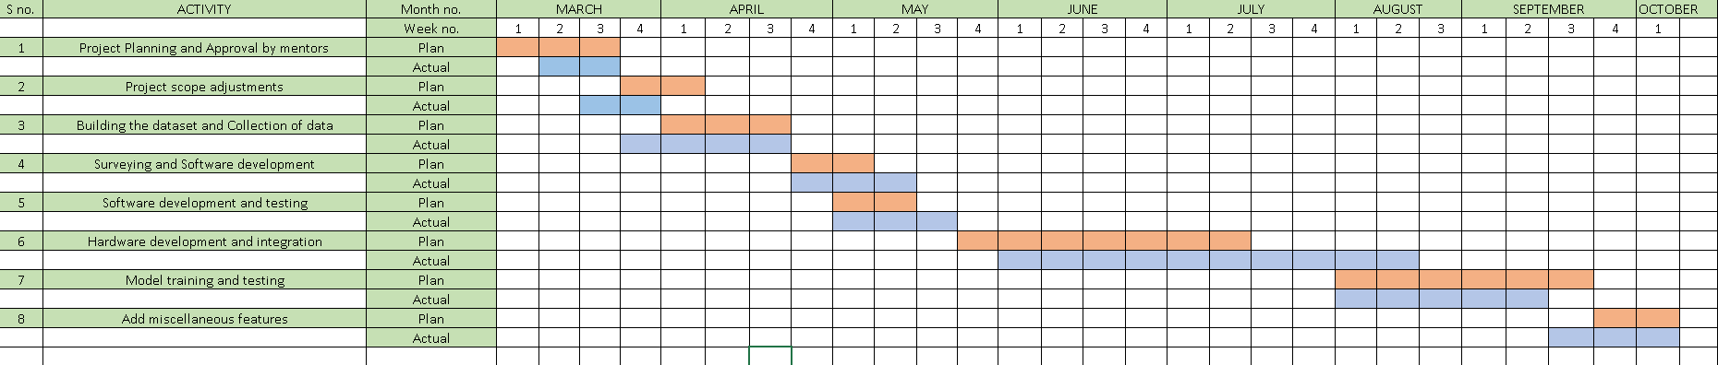**Harsheen Kaur**

**Figure 7.2 Gantt chart (Harsheen Kaur)**

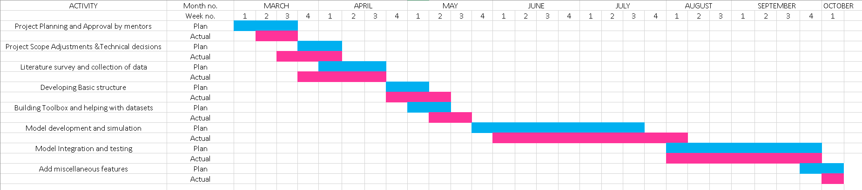**Aditi Puri**

**Figure 7.3 Gantt chart (Aditi Puri)**

**Mansi Gupta**

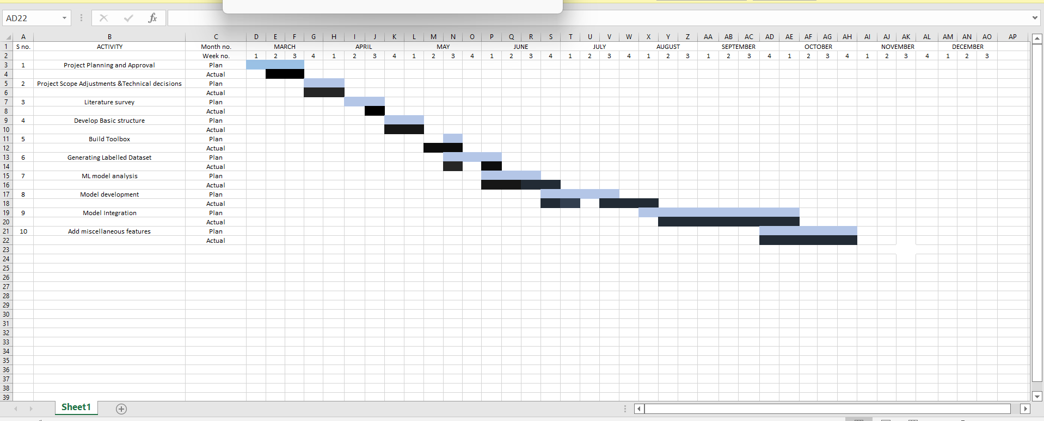

**Figure 7.4 Gantt chart (Mansi Gupta)**

**Yashna Bawa**

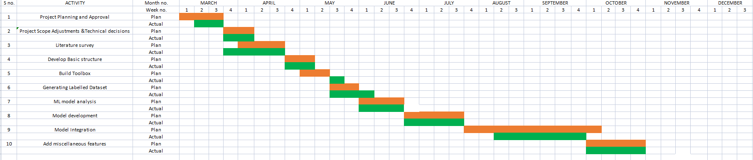

**Figure 7.5 Gantt chart (Yashna Bawa)**

**Mridul Sharma**

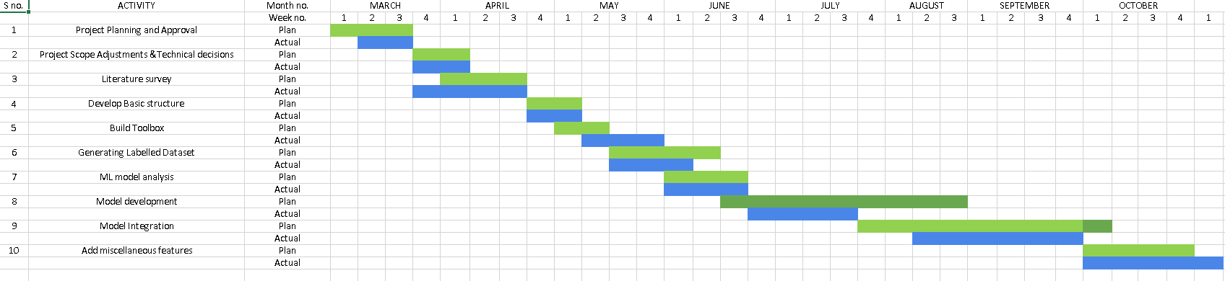

**Figure 7.6 Gantt chart (Mridul Sharma)**

**7.4. PROJECT TIMELINE**

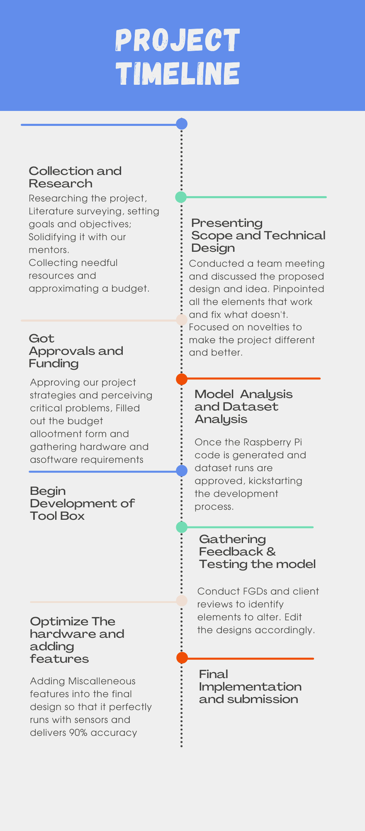

**Figure 7.7 Project timeline**

**Table 7.2 Course Learning Outcomes**

|  |  |
| --- | --- |
| For Capstone project the students of undergraduate program in Electronics and Communication Engineering/Electronics and Computer Engineering will have | |
| C. an ability to design a system, component, or process to meet desired needs within realistic constraints such as economic, environmental, social, political, ethical, health and safety, manufacturability, and sustainability. | |
| Yes/No | |
| C1. Analyze needs to produce problem definition for electronics and communication systems. | Yes |
| C2. Carries out design process to satisfy project requirement for electronics and communication systems | Yes |
| C3. Can work within realistic constraints in realizing systems. | Yes |
| C4. Can build prototypes that meet design specifications. | Yes |
| D. an ability to function on multidisciplinary teams. | |
| D1. Shares responsibility and information schedule with others in team | Yes |
| D2. Participates in the development and selection of ideas. | Yes |
| G. an ability to communicate effectively. | |
| G1. Produce a variety of documents such as laboratory or project reports using appropriate formats and grammar with discipline specific conventions including citations. | Yes |
| G2. Deliver well organized, logical oral presentation, including good explanations when questioned. | Yes |

|  |  |
| --- | --- |
| H. The broad education necessary to understand the impact of engineering solutions in a global, economic, environmental, and societal context. | |
| H1. Aware of societal and global changes that engineering innovations may cause. | Yes |
| H2. Examines economics trade offs in engineering systems. | Yes |
| H3. Evaluates engineering solutions that consider environmental factors. | Yes |
| I. a recognition of the need for, and an ability to engage in life-long learning. | |
| I1. Able to use resources to learn new devices and systems, not taught in class. | Yes |
| I2. Ability to list sources for continuing education opportunities. | Yes |
| I3. Recognizes the need to accept persona responsibility for learning and of the importance of lifelong learning. | Yes |
| K. an ability to use the techniques, skills, and modern engineering tools necessary for engineering practice. | |
| K1. Able to operate engineering equipment | Yes |
| K2. Able to program engineering devices. | Yes |
| K3. Able to use electronic devices, circuits and systems modeling software for engineering applications | Yes |
| K4. Able to analyze engineering problems using software tools | Yes |

**REFERENCES**

1. *Global Status Report on Road Safety 2009.* World Health Organisation (WHO); Geneva, Switzerland: 2009. [[Google Scholar](https://scholar.google.com/scholar_lookup?title=Global+Status+Report+on+Road+Safety+2009&publication_year=2009&)]

2. Rau P. *Drowsy Driver Detection and Warning System for Commercial Vehicle Drivers: Field Operational Test Design, Analysis, and Progress.* National Highway Traffic Safety Administration; Washington, DC, USA: 2005. [[Google Scholar](https://scholar.google.com/scholar_lookup?title=Drowsy+Driver+Detection+and+Warning+System+for+Commercial+Vehicle+Drivers:+Field+Operational+Test+Design,+Analysis,+and+Progress&author=P.+Rau&publication_year=2005&)]

3. *Drivers Beware Getting Enough Sleep Can Save Your Life This Memorial Day.* National Sleep Foundation (NSF); Arlington, VA, USA: 2010. [[Google Scholar](https://scholar.google.com/scholar_lookup?title=Drivers+Beware+Getting+Enough+Sleep+Can+Save+Your+Life+This+Memorial+Day&publication_year=2010&)]

4. Husar P. Eyetracker Warns against Momentary Driver Drowsiness. Available online: <http://www.fraunhofer.de/en/press/research-news/2010/10/eye-tracker-driver-drowsiness.html> (accessed on 27 July 2012).

5. Liu C.C., Hosking S.G., Lenné M.G. Predicting driver drowsiness using vehicle measures: Recent insights and future challenges. *J. Saf. Res.*2009;**40**:239–245. [[PubMed](https://pubmed.ncbi.nlm.nih.gov/19778647)] [[Google Scholar](https://scholar.google.com/scholar_lookup?journal=J.+Saf.+Res&title=Predicting+driver+drowsiness+using+vehicle+measures:+Recent+insights+and+future+challenges&author=C.C.+Liu&author=S.G.+Hosking&author=M.G.+Lenn%C3%A9&volume=40&publication_year=2009&pages=239-245&)]

6. Forsman P.M., Vila B.J., Short R.A., Mott C.G., van Dongen H.P.A. Efficient driver drowsiness detection at moderate levels of drowsiness. *Accid. Anal. Prevent.*2012 in press. [[PubMed](https://pubmed.ncbi.nlm.nih.gov/22647383)] [[Google Scholar](https://scholar.google.com/scholar_lookup?journal=Accid.+Anal.+Prevent.&title=Efficient+driver+drowsiness+detection+at+moderate+levels+of+drowsiness&author=P.M.+Forsman&author=B.J.+Vila&author=R.A.+Short&author=C.G.+Mott&author=H.P.A.+van+Dongen&publication_year=2012&)]

7. Xiao F., Bao C.Y., Yan F.S. Yawning detection based on gabor wavelets and LDA. *J. Beijing Univ. Technol.*2009;**35**:409–413. [[Google Scholar](https://scholar.google.com/scholar_lookup?journal=J.+Beijing+Univ.+Technol&title=Yawning+detection+based+on+gabor+wavelets+and+LDA&author=F.+Xiao&author=C.Y.+Bao&author=F.S.+Yan&volume=35&publication_year=2009&pages=409-413&)]

8. Zhang Z., Zhang J. A new real-time eye tracking based on nonlinear unscented Kalman filter for monitoring driver fatigue. *J. Contr. Theor. Appl.*2010;**8**:181–188. [[Google Scholar](https://scholar.google.com/scholar_lookup?journal=J.+Contr.+Theor.+Appl&title=A+new+real-time+eye+tracking+based+on+nonlinear+unscented+Kalman+filter+for+monitoring+driver+fatigue&author=Z.+Zhang&author=J.+Zhang&volume=8&publication_year=2010&pages=181-188&)]

9. Yin B.-C., Fan X., Sun Y.-F. Multiscale dynamic features based driver fatigue detection. *Int. J. Pattern Recogn. Artif. Intell.*2009;**23**:575–589. [[Google Scholar](https://scholar.google.com/scholar_lookup?journal=Int.+J.+Pattern+Recogn.+Artif.+Intell&title=Multiscale+dynamic+features+based+driver+fatigue+detection&author=B.-C.+Yin&author=X.+Fan&author=Y.-F.+Sun&volume=23&publication_year=2009&pages=575-589&)]

10. Akin M., Kurt M., Sezgin N., Bayram M. Estimating vigilance level by using EEG and EMG signals. *Neural Comput. Appl.*2008;**17**:227–236. [[Google Scholar](https://scholar.google.com/scholar_lookup?journal=Neural+Comput.+Appl&title=Estimating+vigilance+level+by+using+EEG+and+EMG+signals&author=M.+Akin&author=M.+Kurt&author=N.+Sezgin&author=M.+Bayram&volume=17&publication_year=2008&pages=227-236&)]

11. Kokonozi A.K., Michail E.M., Chouvarda I.C., Maglaveras N.M. A Study of Heart Rate and Brain System Complexity and Their Interaction in Sleep-Deprived Subjects. Proceedings of the Conference Computers in Cardiology; Bologna, Italy. 14–17 September 2008; pp. 969–971. [[Google Scholar](https://scholar.google.com/scholar?q=Kokonozi+A.K.+Michail+E.M.+Chouvarda+I.C.+Maglaveras+N.M.+A+Study+of+Heart+Rate+and+Brain+System+Complexity+and+Their+Interaction+in+Sleep-Deprived+Subjects+Proceedings+of+the+Conference+Computers+in+Cardiology+Bologna,+Italy+14%E2%80%9317+September+2008+969+971+)]

12. Khushaba R.N., Kodagoda S., Lal S., Dissanayake G. Driver drowsiness classification using fuzzy wavelet-packet-based feature-extraction algorithm. *IEEE Trans. Biomed. Eng.*2011;**58**:121–131. [[PubMed](https://pubmed.ncbi.nlm.nih.gov/20858575)] [[Google Scholar](https://scholar.google.com/scholar_lookup?journal=IEEE+Trans.+Biomed.+Eng&title=Driver+drowsiness+classification+using+fuzzy+wavelet-packet-based+feature-extraction+algorithm&author=R.N.+Khushaba&author=S.+Kodagoda&author=S.+Lal&author=G.+Dissanayake&volume=58&publication_year=2011&pages=121-131&pmid=20858575&)]

13. Liang W., Yuan J., Sun D., Lin M. Changes in physiological parameters induced by indoor simulated driving: Effect of lower body exercise at mid-term break. *Sensors.*2009;**9**:6913–6933. [[PMC free article](https://www.ncbi.nlm.nih.gov/pmc/articles/PMC3290476/)] [[PubMed](https://pubmed.ncbi.nlm.nih.gov/22399979)] [[Google Scholar](https://scholar.google.com/scholar_lookup?journal=Sensors&title=Changes+in+physiological+parameters+induced+by+indoor+simulated+driving:+Effect+of+lower+body+exercise+at+mid-term+break&author=W.+Liang&author=J.+Yuan&author=D.+Sun&author=M.+Lin&volume=9&publication_year=2009&pages=6913-6933&pmid=22399979&)]

14. Guosheng Y., Yingzi L., Prabir B. A driver fatigue recognition model based on information fusion and dynamic Bayesian network. *Inform. Sci.*2010;**180**:1942–1954. [[Google Scholar](https://scholar.google.com/scholar_lookup?journal=Inform.+Sci&title=A+driver+fatigue+recognition+model+based+on+information+fusion+and+dynamic+Bayesian+network&author=Y.+Guosheng&author=L.+Yingzi&author=B.+Prabir&volume=180&publication_year=2010&pages=1942-1954&)]

15. Philip P., Sagaspe P., Moore N., Taillard J., Charles A., Guilleminault C., Bioulac B. Fatigue, sleep restriction and driving performance. *Accid. Anal. Prevent.*2005;**37**:473–478. [[PubMed](https://pubmed.ncbi.nlm.nih.gov/15784201)] [[Google Scholar](https://scholar.google.com/scholar_lookup?journal=Accid.+Anal.+Prevent&title=Fatigue,+sleep+restriction+and+driving+performance&author=P.+Philip&author=P.+Sagaspe&author=N.+Moore&author=J.+Taillard&author=A.+Charles&volume=37&publication_year=2005&pages=473-478&)]

16. Tremaine R., Dorrian J., Lack L., Lovato N., Ferguson S., Zhou X., Roach G. The relationship between subjective and objective sleepiness and performance during a simulated night-shift with a nap countermeasure. *Appl. Ergon.*2010;**42**:52–61. [[PubMed](https://pubmed.ncbi.nlm.nih.gov/20471003)] [[Google Scholar](https://scholar.google.com/scholar_lookup?journal=Appl.+Ergon&title=The+relationship+between+subjective+and+objective+sleepiness+and+performance+during+a+simulated+night-shift+with+a+nap+countermeasure&author=R.+Tremaine&author=J.+Dorrian&author=L.+Lack&author=N.+Lovato&author=S.+Ferguson&volume=42&publication_year=2010&pages=52-61&pmid=20471003&)]

17. Brodbeck V., Kuhn A., von Wegner F., Morzelewski A., Tagliazucchi E., Borisov S., Michel C.M., Laufs H. EEG microstates of wakefulness and NREM sleep. *NeuroImage.*2012;**62**:2129–2139. [[PubMed](https://pubmed.ncbi.nlm.nih.gov/22658975)] [[Google Scholar](https://scholar.google.com/scholar_lookup?journal=NeuroImage&title=EEG+microstates+of+wakefulness+and+NREM+sleep&author=V.+Brodbeck&author=A.+Kuhn&author=F.+von+Wegner&author=A.+Morzelewski&author=E.+Tagliazucchi&volume=62&publication_year=2012&pages=2129-2139&pmid=22658975&)]

18. *Drowsy Driving and Automobile Crashes.* National Center on Sleep Disorder Research and the National Highway Traffic Safety Administration; Howe, TX, USA: 1998. [[Google Scholar](https://scholar.google.com/scholar_lookup?title=Drowsy+Driving+and+Automobile+Crashes&publication_year=1998&)]

19. Rosey F., Auberlet J.-M., Moisan O., Dupre G. Impact of narrower lane width: Comparison between fixed-base simulator and real data. *Transport. Res. Rec. J. Transport. Res. Board.*2009;**2138**:112–119. [[Google Scholar](https://scholar.google.com/scholar_lookup?journal=Transport.+Res.+Rec.+J.+Transport.+Res.+Board&title=Impact+of+narrower+lane+width:+Comparison+between+fixed-base+simulator+and+real+data&author=F.+Rosey&author=J.-M.+Auberlet&author=O.+Moisan&author=G.+Dupre&volume=2138&publication_year=2009&pages=112-119&)]

20. Konstantopoulos P., Chapman P., Crundall D. Driver’s visual attention as a function of driving experience and visibility. Using a driving simulator to explore drivers’ eye movements in day, night and rain driving. *Accid. Anal. Prevent.*2010;**42**:827–834. [[PubMed](https://pubmed.ncbi.nlm.nih.gov/20380909)] [[Google Scholar](https://scholar.google.com/scholar_lookup?journal=Accid.+Anal.+Prevent&title=Driver%E2%80%99s+visual+attention+as+a+function+of+driving+experience+and+visibility.+Using+a+driving+simulator+to+explore+drivers%E2%80%99+eye+movements+in+day,+night+and+rain+driving&author=P.+Konstantopoulos&author=P.+Chapman&author=D.+Crundall&volume=42&publication_year=2010&pages=827-834&)]

21. Kaptein N., Theeuwes J., van der Horst R. Driving simulator validity: Some considerations. *Transport. Res. Rec. J. Transport. Res. Board.*1996;**1550**:30–36. [[Google Scholar](https://scholar.google.com/scholar_lookup?journal=Transport.+Res.+Rec.+J.+Transport.+Res.+Board&title=Driving+simulator+validity:+Some+considerations&author=N.+Kaptein&author=J.+Theeuwes&author=R.+van+der+Horst&volume=1550&publication_year=1996&pages=30-36&)]

22. Bella F. Driver perception of roadside configurations on two-lane rural roads: Effects on speed and lateral placement. *Accid. Anal. Prevent.*2012 in press. [[PubMed](https://pubmed.ncbi.nlm.nih.gov/22595299)] [[Google Scholar](https://scholar.google.com/scholar_lookup?journal=Accid.+Anal.+Prevent.&title=Driver+perception+of+roadside+configurations+on+two-lane+rural+roads:+Effects+on+speed+and+lateral+placement&author=F.+Bella&publication_year=2012&)]

23. Auberlet J.-M., Rosey F., Anceaux F., Aubin S., Briand P., Pacaux M.-P., Plainchault P. The impact of perceptual treatments on driver’s behavior: From driving simulator studies to field tests—First results. *Accid. Anal. Prevent.*2012;**45**:91–98. [[PubMed](https://pubmed.ncbi.nlm.nih.gov/22269489)] [[Google Scholar](https://scholar.google.com/scholar_lookup?journal=Accid.+Anal.+Prevent&title=The+impact+of+perceptual+treatments+on+driver%E2%80%99s+behavior:+From+driving+simulator+studies+to+field+tests%E2%80%94First+results&author=J.-M.+Auberlet&author=F.+Rosey&author=F.+Anceaux&author=S.+Aubin&author=P.+Briand&volume=45&publication_year=2012&pages=91-98&)]

24. Johnson M.J., Chahal T., Stinchcombe A., Mullen N., Weaver B., Bédard M. Physiological responses to simulated and on-road driving. *Int. J. Psychophysiol.*2011;**81**:203–208. [[PubMed](https://pubmed.ncbi.nlm.nih.gov/21726587)] [[Google Scholar](https://scholar.google.com/scholar_lookup?journal=Int.+J.+Psychophysiol&title=Physiological+responses+to+simulated+and+on-road+driving&author=M.J.+Johnson&author=T.+Chahal&author=A.+Stinchcombe&author=N.+Mullen&author=B.+Weaver&volume=81&publication_year=2011&pages=203-208&pmid=21726587&)]

25. Mayhew D.R., Simpson H.M., Wood K.M., Lonero L., Clinton K.M., Johnson A.G. On-road and simulated driving: Concurrent and discriminant validation. *J. Safety Res.*2011;**42**:267–275. [[PubMed](https://pubmed.ncbi.nlm.nih.gov/22017829)] [[Google Scholar](https://scholar.google.com/scholar_lookup?journal=J.+Safety+Res&title=On-road+and+simulated+driving:+Concurrent+and+discriminant+validation&author=D.R.+Mayhew&author=H.M.+Simpson&author=K.M.+Wood&author=L.+Lonero&author=K.M.+Clinton&volume=42&publication_year=2011&pages=267-275&pmid=22017829&)]

26. Ingre M., ÅKerstedt T., Peters B., Anund A., Kecklund G. Subjective sleepiness, simulated driving performance and blink duration: Examining individual differences. *J. Sleep Res.*2006;**15**:47–53. [[PubMed](https://pubmed.ncbi.nlm.nih.gov/16490002)] [[Google Scholar](https://scholar.google.com/scholar_lookup?journal=J.+Sleep+Res&title=Subjective+sleepiness,+simulated+driving+performance+and+blink+duration:+Examining+individual+differences&author=M.+Ingre&author=T.+%C3%85Kerstedt&author=B.+Peters&author=A.+Anund&author=G.+Kecklund&volume=15&publication_year=2006&pages=47-53&pmid=16490002&)]

28. Hu S., Zheng G. Driver drowsiness detection with eyelid related parameters by support vector machine. *Exp. Syst. Appl.*2009;**36**:7651–7658. [[Google Scholar](https://scholar.google.com/scholar_lookup?journal=Exp.+Syst.+Appl&title=Driver+drowsiness+detection+with+eyelid+related+parameters+by+support+vector+machine&author=S.+Hu&author=G.+Zheng&volume=36&publication_year=2009&pages=7651-7658&)]

29. Peters R.D., Wagner E., Alicandri E., Fox J.E., Thomas M.L., Thorne D.R., Sing H.C., Balwinski S.M. Effects of partial and total sleep deprivation on driving performance. *Publ. Road.*1999;**62**:2–6. [[Google Scholar](https://scholar.google.com/scholar_lookup?journal=Publ.+Road&title=Effects+of+partial+and+total+sleep+deprivation+on+driving+performance&author=R.D.+Peters&author=E.+Wagner&author=E.+Alicandri&author=J.E.+Fox&author=M.L.+Thomas&volume=62&publication_year=1999&pages=2-6&)]

30. Lal S.K.L., Craig A. A critical review of the psychophysiology of driver fatigue. *Biol. Psychol.*2001;**55**:173–194. [[PubMed](https://pubmed.ncbi.nlm.nih.gov/11240213)] [[Google Scholar](https://scholar.google.com/scholar_lookup?journal=Biol.+Psychol&title=A+critical+review+of+the+psychophysiology+of+driver+fatigue&author=S.K.L.+Lal&author=A.+Craig&volume=55&publication_year=2001&pages=173-194&pmid=11240213&)]

31. Horne J., Reyner L. Vehicle accidents related to sleep: A review. *Occup. Environ. Med.*1999;**56**:289–294. [[PMC free article](https://www.ncbi.nlm.nih.gov/pmc/articles/PMC1757738/)] [[PubMed](https://pubmed.ncbi.nlm.nih.gov/10472301)] [[Google Scholar](https://scholar.google.com/scholar_lookup?journal=Occup.+Environ.+Med&title=Vehicle+accidents+related+to+sleep:+A+review&author=J.+Horne&author=L.+Reyner&volume=56&publication_year=1999&pages=289-294&pmid=10472301&)]

32. Otmani S., Pebayle T., Roge J., Muzet A. Effect of driving duration and partial sleep deprivation on subsequent alertness and performance of car drivers. *Physiol. Behav.*2005;**84**:715–724. [[PubMed](https://pubmed.ncbi.nlm.nih.gov/15885247)] [[Google Scholar](https://scholar.google.com/scholar_lookup?journal=Physiol.+Behav&title=Effect+of+driving+duration+and+partial+sleep+deprivation+on+subsequent+alertness+and+performance+of+car+drivers&author=S.+Otmani&author=T.+Pebayle&author=J.+Roge&author=A.+Muzet&volume=84&publication_year=2005&pages=715-724&pmid=15885247&)]